ATTACHMENT 1 – RECOMMENDED CONDITIONS OF CONSENT

Council has imposed the following conditions under the relevant planning instruments and policies.

PART 1:

DEFERRED COMMENCEMENT

Development consent shall be deferred pursuant to Section 4.16(3) of the Environmental Planning and Assessment Act 1979, until the submission to Council of:

Voluntary Planning Agreement

- Amendments to the Voluntary Planning Agreement applicable to this site executed by Tanlane Pty Ltd and Liverpool City Council (dated 11 June 2008) shall be completed prior to the issue of any operative consent. The amendment shall ensure that Item 1e on annexure 1 of the existing Agreement is removed and replaced with the granting of an easement in perpetuity for public access to the open space or as alternatively agreed by Council. The amendment shall also ensure deletion of easement for bridge over entrance to the Marina.

Intersection of Brickmaker’s Drive and new Link Road

- The applicant is to obtain in-principle approval for the installation of traffic control signals at the intersection of Brickmakers Drive and new Link Road from TfNSW. In order to obtain in principle approval, the applicant is required to submit the design of the proposed traffic control signals at the intersection of Brickmakers Drive and the new Link Road in accordance with the TfNSW and Council requirements. The Traffic Control Signal (TCS) plans shall be drawn by a suitably qualified person and endorsed by a suitably qualified practitioner.

The road layout for the TCS and a revised SIDRA model is to be submitted to Council’s Traffic and Transport Section for endorsement prior to detailed design. The road layout is to be made up of the following:

- Two southbound lanes from Newbridge Road to the intersection with the new Link Road.
- The northbound to accommodate the right turn bay for the 95-percentile queue and two northbound lanes.
- The eastern approach is to accommodate a right-turn bay for the 95-percentle queue and a left-turn lane.

The submitted design shall be in accordance with Austroads Guide to Road Design in association with relevant TfNSW supplements (available on www.rms.nsw.gov.au). The certified copies of the signal design and civil design plans shall be submitted to TfNSW and Council’s Manager of Development Assessment for review and approval. Documents should be submitted to Development.Sydney@rms.gov.au.

Rock Armouring

- A Rock Armouring Revetment Works Method Statement shall be provided to Council and TfNSW for their notification and review. This Statement shall describe the rock armouring works, the methods that will be used for its construction, and must ensure that any water from dewatering works is discharged to the enclosed marina basin.”

Note: The items raised within Part 1, above, are to be addressed within five (5) years of the date shown on Council’s determination notice. The consent shall become operative once Council has notified the applicant in writing that the evidence submitted in response to the “Deferred Commencement” conditions is acceptable.
PART 2

On the submission of the required evidence and on the applicant receiving written notification that Council is satisfied that the matters listed in “Part 1” have been satisfied, then the consent shall become operative subject to compliance with conditions outlined in “Part 2”.

A. THE DEVELOPMENT

Approved Plans

- Development the subject of this determination notice must be carried out strictly in accordance with the accompanying plans and reports listed below and stamped DA-611/2018, except where modified by the undermentioned conditions:

- Plans:

Drawing Title | Drawing No. | Issue | Prepared by | Date
Plan showing boundary and proposed Marina | 14005E41 | H | JMD Development Consultants | 06-07-2020
Site – Plan General Layout | DA-001 | L | MFA | 15/04/20
Site – Plan Levels and Contours | DA-002 | I | MFA | 15/04/20
Site – Plan Numbers | DA-003 | L | MFA | 17/10/19
Maritime Building Elevations | DA-110 | E | MFA | 17/10/19
Site – Sections | DA-020 | D | MFA | 17/10/19
Maritime Building Sections | DA-120 | F | MFA | 17/10/19
Elevation – Detail | DA-111 | B | MFA | 17/10/19
Maritime Building Plans – Levels Sub and 1 | DA-100 | H | MFA | 17/10/19
Maritime Building Plans – Levels 2 and 3 | DA-101 | H | MFA | 17/10/19
Maritime Building Plans – Levels 4 and Roof | DA-102 | G | MFA | 17/10/19
Private Marina Clubhouse Elevations | DA-210 | E | MFA | 17/10/19
Private Marina Clubhouse Floor Plans | DA-200 | F | MFA | 17/10/19
Private Marina Clubhouse Sections | DA-220 | E | MFA | 17/10/19
Landscape Plan | Georges Cove Marina, Moorebank | - | EcoHort Pty Ltd | 25 September 2019
Landscape Plan | - | - | MFA | 25.09.2019
Section G-G | WD-20 | D | MFA | 17/10/19
Section H-H | WD-21 | D | MFA | 17/10/19

- Environmental Impact Statement Georges Cove Marina, Moorebank Volume 1-6 (Report J180179, RP1, v3) and Appendices A to K prepared by EMM Consulting dated 24th May 2019;

- Georges Cove Marina, Moorebank, Preliminary Marina Concept Design and Environmental Assessment – Worley Parsons October 2010;

- Remediation Action Plan Proposed Georges Cove Marina (Report J14149RP1, Version V2, Final) prepared by EMM Consulting dated 11th March 2016;

- Preliminary Site Investigation Proposed Rezoning (Area 1) and Georges Cove Marina (Area 2) 146 Newbridge Road, Moorebank (Project 71459.10, Document No. R.001.Rev1, File name 71459.10.R.001.Rev1.PSI, Revision 1) prepared by Douglas Partners Pty Ltd dated 28th May 2018;

- Georges Cove Marina Noise and Vibration Impact Assessment (Report Number: J180179 RP4, Version v1 Final) prepared by EMM Consulting dated 4th April 2019;

- Georges Cove Marina- Background Noise Levels and Project Noise Trigger Levels (Report Reference: J180179, Version v1) prepared by EMM Consulting dated 7th November 2019

- Site Audit Report 282 by Dr Ian Swane Remediation Strategy for Proposed Georges Cove Marina Development at 146 Newbridge Road, Moorebank NSW 2170 (Document No. 1, Revision: Final) dated 27th April 2019;

- Site Audit Statement No. 282 prepared by Dr Ian Swane dated 27th April 2019; and

- Air Quality Assessment for the Proposed Construction and Operation of the Georges Cove Marina prepared by Todoroski Air Sciences dated 14th December 2011.

- Acid Sulfate Soil Management Plan for Georges Cove Marina;

- Waste Management Plan for Georges Cove Marina.

- Navigation Assessment prepared by EMM dated 29 April 2016

- Remediation Strategy and Remedial Action Plan as prepared by EMM, Report Number J180179 RP8, 26 dated March 2021.

- Interim Advice Report for Georges Cove Marina RAP, 146 Newbridge Road, Moorenak – Statutory Site Audit, prepared by Ian Swane & Associates P/L, dated 28 March 2021.

- George’s Cove Marina Response to Planning Panel Questions v8 310321, prepared by Tooker + Associates.

General Terms of Approval

- All General Terms of Approval shall be complied with prior, during, and at the completion of construction and if required during the operation of the marina as required in accordance with the General Terms of Approval. A copy of the General Terms of Approval are attached to this decision notice and include:

- Natural Resources Access Regulator – Water Management Act 2000 dated 18 September 2019;

- Department of Primary Industries – NSW Fisheries – Fisheries Management Act 1994 dated 10 June 2020;

- Environmental Protection Authority – Protection of the Environment Operations Act 1997, dated 19 February 2020;

- NSW Rural Fire Service – Rural Fires Act 1997 dated 2 August 2019;

- Transport for NSW - State Environmental Planning Policy (Infrastructure) 2007, dated 9 September 2020.

Works at no cost to Council

- All roadworks, drainage works and dedications, required to effect the consented development shall be undertaken at no cost to Liverpool City Council.

Requirements of Sydney Water

- The comments provided by Sydney Water shall be complied with prior, during and at the completion of construction, as required in accordance with their correspondence dated 2 May 2019. A copy of their correspondence is found as an Attachment to this decision notice.

Requirements of Endeavour Energy

- The comments provided by Endeavour Energy shall be complied with prior, during and at the completion of construction, as required in accordance with their correspondence found as an Attachment to this decision notice.

Compliance with the Environmental Planning & Assessment Act 1979

- The requirements and provisions of the Environmental Planning & Assessment Act 1979 and Environmental Planning & Assessment Regulation 2000, must be fully complied with at all times.

Failure to comply with these legislative requirements is an offence and may result in the commencement of legal proceedings, issuing of ‘on-the-spot’ penalty infringements or service of a notice and order by Council.

Compliance with the National Construction Code

- In accordance with section 4.17 of the Environmental Planning & Assessment Act 1979 and clause 98 of the Environmental Planning & Assessment Regulation 2000, it is a prescribed condition that all building work must be carried out in accordance with the applicable Performance Requirements of the National Construction Code. Compliance with the Performance Requirements can only be achieved by:

(a) Complying with the Deemed to Satisfy Provisions; or
(b) Formulating an Alternative Solution, which complies with the Performance Requirements or is shown to be at least equivalent to the Deemed to Satisfy Provision, or a combination of (a) and (b).

B. PRIOR TO ISSUE OF A CONSTRUCTION CERTIFICATE

The following conditions shall be complied with prior to issue of a CC by the PCA:

Voluntary Planning Agreement

- Any monetary contributions payable, any actions or works to be undertaken, or any other requirements of the VPA are to be in accordance with the executed Voluntary Planning Agreement applying to this site.

Stormwater Drainage Plan

- Prior to the issue of any Construction Certificate, a detailed stormwater drainage plan prepared by a suitably qualified hydraulic engineer along with necessary hydraulic calculations must be submitted to and endorsed by Council’s Manager of Development Assessment. Evidence shall be submitted to the PCA that the detailed stormwater drainage plan has been reviewed and endorsed by Council’s Manager of Development Assessment.

Construction Traffic Management Plan

- A construction traffic management plan (CTMP) is to be submitted to Liverpool City Council’s Traffic and Transport Section for endorsement

- The CTMP is to be prepared by an accredited practitioner. Works shall not commence until the CTMP has been endorsed. The endorsed CTMP is to be implemented during construction.

Fee Payments

- Unless otherwise prescribed by this consent, all relevant fees or charges must be paid. Where Council does not collect these payments, copies of receipts must be provided. For the calculation of payments such as Long Service Levy, the payment must be based on the value specified with the Development Application/Construction Certificate.

The following fees are applicable and payable:

- Damage Inspection Fee – relevant where the cost of building work is $20,000 or more, or a swimming pool is to be excavated by machinery,
- Fee associated with Application for Permit to Carry Out Work Within a Road, Park and Drainage Reserve, and
- Long Service Levy - based on 0.35% of the cost of the building work where the costing of the CC is $25,000 or more.

These fees are reviewed annually and will be calculated accordingly.

All fees associated with a road opening permit required for the connection, extension or amplification of any services within Council’s road reserve must be paid to Council and receipts provided to the PCA. A separate form must be submitted in conjunction with payment of the fees. The fees include the standard road opening permit fee and any restoration fees that may be required as a result of the works.

- Access must be provided to the building for people with a disability in accordance with the relevant requirements of the Building Code of Australia, Disability (access to Premises – Buildings) Standard 2010 and Australian Standard – AS1428.1 (2009), Design for Access and Mobility – General requirements for new building work, to the satisfaction of the Certifying Authority.

- A fire safety report prepared by an accredited C10 fire engineer, must be submitted to the PCA prior to issue of construction certificate, demonstrating that all proposed external wall cladding materials used for the building complies with the NCC and relevant Australian Standards. The fire safety report is to include evidence of suitability of all proposed external wall cladding materials as per clause A2.2 of the NCC.

- A schedule specifying all of the essential fire safety services, both existing and proposed, which are required for the building, shall be attached to the CC and submitted to Council, in compliance with the provisions of the EP&A Regulation.

- No building products that are banned, or products that are subject to a ban if used in a particular way under the Building Products (Safety) Act 2017 are to be used in the construction of the development.

Site development work

- Site development work in the form of excavation, underpinning or shoring works must not take place, until such time as a CC has been issued.

Detailed plans

- Detailed specifications, floor and section plans for the Marina comprising the mechanical workshop, wash bays, holding tanks, fuel delivery, storage and dispensing facilities shall be submitted to Liverpool City Council and the Principal Certifying Authority for review and approval prior to the issue of a Construction Certificate. The plans to be submitted with the application for the Construction Certificate shall include design certification by a suitably qualified and experienced person to verify compliance with the following legislation and standards:

- The Protection of the Environment Operations Act 1997 and Regulations;
- Department of Environment and Climate Change NSW (now Office of Environment and Heritage) guidelines titled ‘Environmental Action for Marinas, Boatsheds and Slipways’ (DECC 2007/108) dated June 2007 and any subsequent revision approved by the NSW Environment Protection Authority (EPA);
- Australian Standard (AS) 3962:2020 Marina Design;
- Australian Standard (AS) 1940:2017- The Storage and Handling of Flammable and Combustible Liquids;
- Australian Standard (AS) 1657:2018 Fixed platforms, walkways, stairways and ladders - Design, construction and installation; and
- Australian Standard (AS) 1692-2006 Steel tanks for flammable and combustible liquids.

The plans to be submitted with the application for the Construction Certificate shall also make provision for the following:

- Trafficable bunds installed at the entry and exits of the maintenance workshop, storage facilities, fuel storage and dispensing facilities and wash bays for vehicles, vessels, garbage bins and equipment;
- All work and storage areas where spillage may occur shall be bunded. The capacity of the bunded area shall be calculated as being equal to 110% of the largest storage or process vessel/container in the area or 10% of the total volume of vessels/containers accommodated in the area, whichever is the greater.
- The roof covering the fuel storage, delivery and dispensing facilities, maintenance workshop, storage facilities and wash bays for vehicles, vessels, garbage bins and equipment shall contain an overhang of at least 10º to prevent rainwater intrusion. Uncontaminated rainwater shall be directed from the canopy and other roofed areas into stormwater drains;
- The location of spill kits, stormwater pits and stormwater drainage infrastructure;
- Fuel deliveries shall be conducted within the forecourt containment area comprising a roof and adequate bunding;
- The location of the oil/water separator or pre-treatment device for the maintenance workshop, storage facilities and wash bays and their connection to Sydney Water’s sewer in accordance with a Trade Waste Agreement. The oil/water separator servicing the site shall be covered and bunded. The cover shall have an overhang of at least 10º. The bunding shall have sufficient capacity to contain 110% of the capacity of the oil/water separator;
- The garbage/waste storage area shall be clearly identified on the site plan and be located within the proposed building. The designated garbage/waste storage area shall comply with the following requirements:
  - The room shall be fully enclosed and provided with a concrete floor, and with concrete or cement rendered walls coved to the floor;
  - The room shall have a floor waste which is to consist of a removable basket within a fixed basket arrestor and is to comply with Sydney Water requirements; and
  - The room shall be adequately ventilated and provided with a door that is tight-fitting and self-closing.

Provision of Services

- An application to obtain a Section 73 Compliance Certificate under the Sydney Water Act 1994, must be lodged with Sydney Water. To facilitate this, an application must be made through an authorised Water Servicing Coordinator. Please refer to the “building and developing” section of Sydney Water’s web site at www.sydneywater.com.au, or telephone 13 20 92.

Following receipt of the application, a ‘Notice of Requirements’ will detail water and sewer extensions to be built and charges to be paid. Please make early contact with the Coordinator, since building of water/sewer extensions can be time consuming and may impact on other services and building, driveway or landscape design. A copy of the ‘Notice of Requirements’ must be submitted to the PCA.

- Written clearance from Endeavour Energy, stating that electrical services have been made available to the development or that arrangements have been entered into for the provision of services to the development must be submitted to the PCA.

- Prior to the issue of a Construction Certificate, the Principal Certifying Authority shall be satisfied that telecommunications infrastructure may be installed to service the premises which complies with the following:

- The requirements of the Telecommunications Act 1997;
- For a fibre ready facility, the NBN Co’s standard specifications current at the time of
- installation; and
- For a line that is to connect a lot to telecommunications infrastructure external to the premises, the line shall be located underground.

Unless otherwise stipulated by telecommunications legislation at the time of construction, the development must be provided with all necessary pits and pipes, and conduits to accommodate the future connection of optic fibre technology telecommunications.

Sewage Pump-Out

- Sewage pump-out facilities are required at the Marina to convey wastewater from vessels to the reticulated sewer. Separate approval is required under Section 68 of the Local Government Act 1993 to install, construct or alter a waste treatment device and operate a system of sewage management at the premises. "Operate a system of sewage management" means to hold or process, or re-use or discharge, sewage or by-products of sewage (whether or not the sewage is generated on the premises on which the system of sewage management is operated).

An application for Approval to Install an On-site Sewage Management System pursuant to Section 68 of the Local Government Act 1993 shall be submitted to Council for consideration and approval prior to issue of a Construction Certificate. The application shall be accompanied by a detailed wastewater report prepared by a suitably qualified consultant which demonstrates that the system’s design and capacity are adequate for its intended purpose taking into consideration maximum load requirements, unforeseen incidents and shutdown contingencies.

The detailed wastewater report shall be prepared by an Environmental Scientist or Engineer with a minimum of a bachelor’s degree qualification and extensive industry experience within an on-site sewage management context. Note: There is currently no certification body for this field.

Recommendations of Acoustic Report

- The recommendations provided in the approved acoustic report titled ‘Georges Cove Marina Noise and Vibration Impact Assessment’ (Report Number: J180179 RP4, Version v1 Final) prepared by EMM Consulting dated 4th April 2019 shall be implemented and incorporated into the design and construction of the development and be shown on plans accompanying the Construction Certificate application. The construction methodology and plans accompanying the Construction Certificate application shall be assessed and certified in writing by a suitably qualified acoustic consultant to verify conformance with the requirements of the aforementioned acoustic report. The written certification from the suitably qualified acoustic consultant shall be submitted to and approved by the Principal Certifying Authority (PCA) prior to issue of the Construction Certificate.

Note: ‘Suitably qualified acoustic consultant’ means a consultant who possesses the qualifications to render them eligible for membership of the Australian Acoustical Society or employed by an Association of Australasian Acoustical Consultants (AAAC) member firm.

Food Premises - Construction

- To ensure compliance with the relevant standards and requirements, the following details are to be submitted to the Principal Certifying Authority for approval:

- Plans, to scale, demonstrating the proposed floor layout as well as associated works is in compliance with:
  - AS4674-2004 – Design, construction and fit-out of food premises,
  - Food Standards Code (Australia),
  - Building Code of Australia,
- Proposed/altered mechanical ventilation system/s (Building Code of Australia & Australian Standard 1668 Part 1 & 2).

Construction Noise and Vibration Management Plan (CNVMP)

- A site-specific Construction Noise, Vibration Assessment and Management Plan prepared by a suitably qualified acoustic consultant shall be submitted to and approved by the Principal Certifying Authority (PCA) prior to issue of the Construction Certificate. The Construction Noise, Vibration Assessment and Management Plan must include an assessment of expected noise impacts and detail feasible work practices to be adopted to avoid, remedy or mitigate construction noise and vibration impacts. The Construction Noise, Vibration Assessment and Management Plan shall be consistent with the ‘Interim Construction Noise Guideline’ published by the Department of Environment and Climate Change NSW (DECC 2009/265) dated July 2009 and include, but not necessarily be limited to the following information:

  - Identification of nearby residences and other noise sensitive land uses;
  - Assessment of expected noise impacts;
  - Detailed examination of feasible and reasonable work practices that will be implemented to minimise noise impacts;
  - Strategies to promptly deal with and address noise complaints;
  - Details of performance evaluating procedures (for example, noise monitoring or checking work practices and equipment);
  - Methods for receiving and responding to complaints about construction noise;
  - Procedures for notifying nearby residents of forthcoming works that are likely to produce noise impacts; and
  - Reference to relevant licence and consent conditions.

The Construction Noise, Vibration Assessment and Management Plan must be made available for inspection when requested by the PCA or Liverpool City Council.

Construction Environmental Management Plan (CEMP)

- Prior to issue of a construction certificate, a Construction Environmental Management Plan (CEMP) for the development must be provided to the Principal Certifying Authority for approval. The environmental site management measures must remain in place and be maintained throughout the period of the development. The CEMP must address all environmental aspects of the development’s construction phases, and include, where relevant, but not be limited to, the following:

- Asbestos Management Plan;
- Project Contact Information;
- Site Security Details;
- Timing and Sequencing Information;
- Site Soil and Water Management Plan;
- Noise and Vibration Control Plan;
- Dust Control Plan;
- Air Monitoring;
- Odour Control Plan;
- Health and Safety Plan;
- Waste Management Plan;
- Incident management Contingency; and
- Unexpected Finds Protocol;
- Landfill gas management during earthworks and construction.

The CEMP must be kept on site for the duration of the works and must be made available to Council Officers upon request.

Mechanical Plant and Equipment

- All public address systems, mechanical plant and equipment shall be selected in consultation with a suitably qualified acoustic consultant in accordance with the recommendations of the approved acoustic report titled ‘Georges Cove Marina Noise and Vibration Impact Assessment’ (Report Number: J180179 RP4, Version v1 Final) prepared by EMM Consulting dated 4th April 2019.

Note: ‘Suitably qualified acoustic consultant’ means a consultant who possesses the qualifications to render them eligible for membership of the Australian Acoustical Society or employed by an Association of Australasian Acoustical Consultants (AAAC) member firm.

S138 Roads Act – Minor Works in the public road reserve

- Prior to the issue of a Construction Certificate, a Section 138 Roads Act application/s, including payment of fees, shall be lodged with Liverpool City Council, as the Roads Authority for any works required in a public road. These works may include but are not limited to:
- Vehicular crossings (including kerb reinstatement of redundant vehicular crossings),
- Road opening for utilities and stormwater (including stormwater connection to Council infrastructure), or
- Road occupancy or road closures.
All works shall be carried out in accordance with the Roads Act approval, the development consent including the stamped approved plans, and Liverpool City Council’s.

Retaining Walls on Boundary

- All retaining walls shall be of masonry construction or large sandstone boulders and must be wholly within the property boundary, including footings and agricultural drainage lines. Construction of retaining walls or associated drainage works along common boundaries shall not compromise the structural integrity of any existing structures.
Where a retaining wall exceeds 600mm in height, the wall shall be designed by a practicing structural engineer and a construction certificate must be obtained prior to commencement of works on the retaining wall.
S138 Roads Act – roadworks requiring approval of civil drawings

- Prior to the issue of a Construction Certificate for building or subdivision works the Certifying Authority shall ensure that a S138 Roads Act application, including the payment of application and inspection fees, has been lodged with Liverpool City Council (being the Roads Authority under the Roads Act), for provision of road and drainage in Brickmakers Drive and Newbridge Road as well as the installation of traffic control signals at the intersection of Brickmakers Drive and new Link Road.
Engineering plans are to be prepared in accordance with the development consent, Liverpool City Council’s Design Guidelines and Construction Specification for Civil Works, Austroad Guidelines and best engineering practice.
Note: Where Liverpool City Council is the Certifying Authority for the development the Roads Act approval for the above works may be issued concurrently with the Construction Certificate.

Stormwater Concept Plan

- A stormwater drainage system shall be provided generally in accordance with the concept plans lodged for development approval, prepared by JMD, Ref: 14005M-E2, Sheet 1 of 2 (Overall Plan) & Sheet 2 of 2 (Marina Raingarden), dated 28.11.2019, as amended pursuant to Deferred Commencement Condition 3 of Development Consent DA-611/2018.

- The proposed development and stormwater drainage system shall be designed to ensure that stormwater runoff from upstream properties is conveyed through the site without adverse impact on the development or adjoining properties.
- Engineering plans and supporting calculations for the stormwater drainage system are to be prepared by a suitably qualified engineer and shall accompany the application for a Construction Certificate. The plan shall indicate the method of disposal of all stormwater and must include rainwater tanks, existing ground levels, finish surface levels and sizes of all pipes.
- Prior to the issue of a Construction Certificate the Certifying Authority shall ensure that the stormwater drainage system has been designed in accordance with Liverpool City Council’s Design Guidelines and Construction Specification for Civil Works.

No Loading on Easements

- Prior to the issue of a Construction Certificate the Certifying Authority shall ensure that the foundations of proposed structures adjoining the drainage and/ or services easement have been designed clear of the zone of influence.

Stormwater Discharge – Basement Car parks

- Prior to the issue of a Construction Certificate the Certifying Authority shall ensure that the stormwater drainage system for the basement car park has been designed in accordance with the requirements for pumped systems in AS3500.3:2003 and Council’s Stormwater Drainage Design Specifications for pump out systems for basement carparks.

Water Quality

- Prior to the issue of a Construction Certificate, the Certifying Authority shall ensure that details of a stormwater pre-treatment system have been provided on the stormwater plans and that the design meets pollutant retention criteria in accordance Council’s Development Control Plan.

The Construction Certificate must be supported by:
- Specification & installation details of the stormwater pre-treatment system
- The approval of an operation and maintenance manual/schedule for the stormwater pre-treatment system
A copy of the approved operation and maintenance manual/ schedule shall be submitted to Liverpool City Council with notification of the Construction Certificate issue.

Flooding

- The proposed development shall not have any adverse flooding impact in the vicinity as indicated in the flood impact assessment report by Cardno (NSW/ACT) Pty Ltd (Ref: NA49913037-L02:BCP/bcp; Flood Impact Assessment for the proposed Georges Cove Marina, Moorebank; dated: 29 January 2013).

- The development of the proposed marina shall be undertaken as indicated in the flood impact assessment report by Cardno (NSW/ACT) Pty Ltd (Ref: NA49913037-L02:BCP/bcp; Flood Impact Assessment for the proposed Georges Cove Marina, Moorebank; dated: 29 January 2013)) and drawings by Micheal Fountain Architects Pty Ltd (Site – Plan, General Layout, Job No. 0914, Drawing No. DA-001, Issue F, dated: 06 May 2019 and accompanying plans, elevations and sections approved under this application).

- There shall be no net loss of floodplain storage volume below the 1% AEP flood by the proposed development.

- The eastern and western sides of the Maritime building shall be maintained open between 4.6m and 5.6m Australian Height Datum to allow free and unobstructed flow of floodwater at all times.

- The eastern and western sides of the Marina Club building shall be maintained open between 4.6m and 5.6m Australian Height Datum to allow free and unobstructed flow of floodwater at all times.

- Level 2 of Maritime and Marina Club buildings shall be no lower than the 1% AEP flood plus half a metre freeboard (i.e. 5.6m + 0.5m = 6.1m Australian Height Datum).

- The structure shall be constructed from flood compatible building components below the 1% AEP flood plus half a metre freeboard (i.e. 5.6m + 0.5m = 6.1m Australian Height Datum).

- The structures, materials and finishes at Level 1 of Maritime and Marina Club buildings shall be made of flood-proof materials and finishes as indicated in the site-specific assessment of Marina building floor level by Tooker+ Associates Pty Ltd (Ref: Georges Cove Marina Floor Level Justification v3 310720, dated: 31 July 2020).

- An engineer’s report shall be required to certify that the structure can withstand the forces of floodwater including debris and buoyancy up to and including a 1% AEP flood plus half a metre freeboard (i.e. 5.6m + 0.5m = 6.1m Australian Height Datum).

- The car parks shall have suitable warning system, signage and exits to ensure safe evacuation during flooding.

- Barriers shall be provided to the car parking site to prevent floating vehicles from leaving the site during a flood event. The barriers shall be designed with large openings only to hold the cars from floating without providing obstruction to flood waters.

- Barriers shall be provided to the boat storage area to prevent the boats being washed away during a flood event. The barriers shall be designed with large openings only to hold the boats without providing obstruction to flood waters.

- Fencing, screen or façade between 4.6m and 6.1m Australian Height Datum shall be limited to permeable open type and shall not obstruct the flow of floodwaters.

- Fencing, screen or façade shall be constructed to withstand the force of floodwaters or collapse in a controlled manner so as not to obstruct the flow of water, become unsafe during times of flood or become moving debris.

- Reliable access for pedestrians or vehicles shall be provided from the lowest floor level to a location above the Probable Maximum Flood.

- Petroleum and other hazardous chemicals shall not be discharged from the site into adjoining waterways and stormwater system. Appropriate pollution control measures shall be provided to collect, treat and dispose hazardous pollutants from the site.

- On-site water quality treatment facilities shall be provided to ensure that stormwater runoffs leaving the site comply with the Council's water quality standards. The treatment facilities shall capture all gross pollutants and liquid contaminants from the stormwater before discharging into the waterway or Council's stormwater system. Water quality treatment works shall be designed using MUSIC modelling software, and the water quality treatment system performance shall be verified using Council's MUSIC link. Water quality modelling report and electronic copies of MUSIC model shall be submitted to the Council.

Access, Car Parking and Manoeuvring - General

- Detailed design plans for the proposed Brickmakers Drive and the New Link Road traffic control signals, other intersection treatment, road works, driveways, and car parks including swept path analysis, line markings and sign posting prepared in accordance with the DCP and AS2890 shall be submitted to Council’s Traffic and Transport Team for review.

The applicant is required to submit the design of the proposed traffic control signals at the intersection of Brickmakers Drive and the new Link Road in accordance with the TfNSW and Council requirements.

The intersection treatment is to address all Council and TfNSW requirements. Overall, the design should demonstrate that the intersection would accommodate the 95 percentile queue lengths from the SIDRA analysis to Council and TfNSW satisfaction.

- The design is to be accompanied by a certification from a qualified professional that the design of the car parks, driveways, ramps and swept path comply with the relevant Australian Standards and Council DCP.

- For the delivery of the approved Brickmakers Drive and New Link Road traffic signal control intersection improvement, the developer is to enter into a Works Authorisation Deed (WAD) with TfNSW for the installation of the required TCS.

- Detailed design plans for all other roadworks including signs and linemarking are to be submitted to Council’s Traffic and Transport Section for referral to the Liverpool Traffic Committee for endorsement. The drawings are to demonstrate that the signs and linemarking including swept path analysis has been prepared in accordance with the DCP and AS2890 should be submitted to Council’s Traffic and Transport team for review.

Street Lighting

- Street lighting is to be provided for all new and existing streets as part of the proposed development to Liverpool City Council’s standards.

The developer shall engage a level 3 street lighting designer to submit a Public Lighting Design Brief to Council to nominate the streetlights category and illumination requirements.

A street lighting design plan must be prepared by an accredited service provider for approval prior to construction. All street lighting must with the electricity service provider (Endeavor Energy) Street Lighting Policy and illumination requirements and Council’s Street Lighting policy.

Foreshore Protection Works

- Any Construction Certificate that is issued must include but is not limited to all foreshore works including rock work, bank stabilisation works and revegetation works in accordance with approved DA plans and associated construction specifications.

Dilapidation Report

- Prior to the Commencement of Works a dilapidation report of all infrastructure fronting in all existing public roads adjoining the site is to be submitted to Liverpool City Council. The report is to include, but not limited to, the road pavement, kerb and gutter, footpath, services and street trees and is to extend 20m either side of the development.

Waste Storage Area - Construction

- All waste management facilities shall comply with the Liverpool Development Control Plan 2008. Prior to the issue of a Construction Certificate, detailed floor and section plans shall be submitted to and approved by the Principal Certifying Authority for the waste storage area/s. The plans shall identify the location of the waste storage area/s and incorporate the following requirements:

- Sufficient space for access, storage and easy manoeuvring of bins;
- The area is to be fully enclosed and include a solid roof and concrete or cement rendered walls coved to the floor;
- A concrete floor graded to an approved sewer connection comprising a sump and galvanised fine grade drain cover sufficient to prevent coarse pollutants from entering the sewer;
- Adequate ventilation to the external air by natural or mechanical means;
- The door to the room must be tight fitting and self-closing;
- A hose cock adjacent to the garbage storage area to facilitate cleaning of bins and the storage area. If the hose cock is located inside the waste storage area, it shall not protrude into the space indicated for the placement of bins;
- Sufficient lighting to permit usage at night; and
- Should garbage chutes be integrated into the design of the building, operational instructions shall be located prominently next to the chute.

Any modifications to the construction of the waste storage area require Council’s prior written Approval.

Waste Storage Area

- Any bin bays must be:

  - Provided with mechanical ventilation,
  - Provided with a hose cock for hosing the garbage bin bay and a sewered drainage point in or adjacent to the bin storage area. The drainage point should have a fine grade drain cover sufficient to prevent coarse pollutants from entering the sewer. If the hose cock is located inside the bin storage bay, it is not to protrude into the space indicated for the placement of bins,
  - Provided with sufficient light to permit usage at night,
  - Allocated with sufficient space within the bin bay to allow for access to all required bins by residents and waste collectors, as well as manoeuvring of bins within the bay and for the removal and return of bins by the waste collector,
  - Bin bay signs are available from Council,
  - Should garbage chutes be incorporated into the design of the building, signage on how to use the chutes is to be located prominently next to the chute,
  - Operation, maintenance and cleaning of the garbage compactor and associated equipment is the responsibility of the strata management or body corporate and not of Council,
  - Maximum compaction ratio is 2:1,
  - Operation, maintenance and cleaning of the garbage chutes and associated waste cupboards, rooms, or equipment is the responsibility of the strata management or body corporate, and not of Council, and
  - Provided with signage to be prominently displayed in each bin bay, or waste service room, as appropriate indicating that:
    - Garbage is to be placed wholly within the garbage bins provided,
    - Only recyclable materials accepted by Council are to be placed within the recycling bins,
    - The area is to be kept tidy,
    - A phone number to be displayed for arranging disposal of bulky items; and
    - 50% of all messages are to be displayed using graphic illustrative content.

Crime Prevention Through Environmental Design

- The following Crime Prevention through Environmental Design (CPTED) principles are to be incorporated into the building:

- back to base alarm system (only if commercial near residential),
- basement parking areas shall be painted a light colour,
- CCTV for the ground level, entry/exit points, car parks, lifts and the exterior of the building,
- ‘way finding’ signage should be utilised at all major interchanges such as lifts and stair wells,
- lighting is required to be designed in accordance with the Australian and New Zealand Lighting Standard AS 1158. A lighting maintenance policy should be established. Security lighting should be installed in and around the building, and such shall not impact on any adjoining premises. The lighting should be vandal resistant, especially external lighting,
- corrugated ramps to prevent skate boarding activities,
- glazed tiling, patterned, porous and non solid surfaces reduce the reward for graffiti offenders,
- any external approved palisade or pool style fencing shall be black in colour, unless otherwise noted on the approved plans/details, and
- access to the basement parking levels relating to the residential component of the building shall be controlled via a security controlled device.

Where necessary, plans shall be amended to reflect incorporation of the principles and/or details of such to be submitted to the PCA.

C. PRIOR TO WORKS COMMENCING

The following conditions shall be complied with prior to works commencing on the subject site:

Building Works

- Prior to the commencement of any building works, the following requirements must be complied with:

  - A Construction Certificate must be obtained from the Council or an accredited certifier, in accordance with the provisions of the Environmental Planning & Assessment Act 1979.
  - Where a Construction Certificate is obtained from an Accredited Certifier, the applicant shall advise Council of the name, address and contact number of the Accredited Certifier, in accordance with Section 81A (4) of the Act.
  - A copy of the Construction Certificate, the approved development consent plans and consent conditions must be kept on the site at all times and be made available to the Council officers and all building contractors for assessment.
  - A Principal Certifying Authority (PCA) must be appointed to carry out the necessary building inspections and to issue an occupation certificate; and
  - The PCA must advise Council of the intended date to commence work which is the subject of this consent by completing a notice of commencement of building works or subdivision works form, available from Council’s Customer Service Centre. A minimum period of two (2) working days’ notice must be given.

Demolition Works

- Demolition works shall be carried out in accordance with the following:

  - Prior to the commencement of any works on the land, a detailed demolition work plan designed in accordance with the Australian Standard AS 2601-2001 – The Demolition of Structures, prepared by a suitably qualified person with suitable expertise or experience, shall be submitted to and approved by Council and shall include the identification of any hazardous materials, method of demolition, precautions to be employed to minimise any dust nuisance and the disposal methods for hazardous materials,
  - Prior to commencement of any works on the land, the demolition Contractor(s) licence details must be provided to Council, and
  - The handling or removal of any asbestos product from the building/site must be carried out by a SafeWork NSW licensed contractor irrespective of the size or nature of the works. Under no circumstances shall any asbestos on site be handled or removed by a non-licensed person. The licensed contractor shall carry out all works in accordance with NSW SafeWork requirements.

Waste Classification and Disposal of Contaminated Soil and Material

- All soils and material(s), liquid and solid, to be removed from the site must be analysed and classified by an appropriately qualified and certified consultant, in accordance with the Protection of the Environment Operations (Waste) Regulation 2014 and related guidelines, in particular the NSW EPA Waste Classification Guidelines, prior to off-site disposal.

All waste material(s) must be disposed of at an appropriately licensed waste facility for the specific waste. Receipts for the disposal of the waste must be submitted to the Principal Certifying Authority within 30 days of the waste being disposed of.
All waste must be transported by a contractor licenced to transport the specific waste, and in vehicles capable of carting the waste without spillage, and meeting relevant requirements and standards. All loads must be covered prior to vehicles leaving the site.

Notification of Service Providers

- The approved development must be approved through the ‘Sydney Water Tap In’ service to determine whether the development will affect any Sydney Water wastewater and water mains, stormwater drains and/or easement, and if any requirements need to be met. A receipt must be provided to Council.

Please refer to the website www.sydneywater.com.au for more information.

Sediment and Erosion Control Measures

- Prior to commencement of works sediment and erosion control measures shall be installed in accordance with the approved Construction Certificate and to ensure compliance with the Protection of the Environment Operations Act 1997 and Landcom’s publication “Managing Urban Stormwater – Soils and Construction (2004)” – also known as “The Blue Book”.

The erosion and sediment control measures shall remain in place and be maintained until all disturbed areas have been rehabilitated and stabilised.

Environmental Management

- Adequate soil and sediment control measures shall be installed and maintained. Furthermore, suitable site practices shall be adopted to ensure that only clean and unpolluted waters are permitted to enter Council’s stormwater drainage system during construction/demolition. Measures must include, as a minimum:

  - Siltation fencing;
  - Protection of the public stormwater system; and
  - Site entry construction to prevent vehicles that enter and leave the site from tracking loose material onto the adjoining public place.

Schedule Development Works

- Prior to the commencement of construction works, a Scheduled Development Works licence shall be issued by the NSW Environment Protection Authority under the Protection of the Environment Operations Act 1997, to ensure that potential emission sources (including discharges to water) are adequately controlled.

Controlled Activity Approval

- Prior to the commencement of any controlled activity (works) on waterfront land, the consent holder must obtain a Controlled Activity Approval (CAA) under the Water Management Act 2000 from the Natural Resources Access Regulator (NRAR).

Road Occupancy

- Road Occupancy License/s (ROL) should be obtained from the Transport Management Centre for any works that may impact on traffic flows on Newbridge Road during construction activities.

- Road Occupancy Permit/s (ROC) should be obtained from Council’s Traffic and Transport Section for all other works in the public road reserve during construction. Works are not to be carried out until the road occupancy or opening permits have been obtained.

D. DURING CONSTRUCTION

The following conditions shall be complied with during construction:

Identification Survey Report

- The building and external walls are not to proceed past ground floor/reinforcing steel level until such time as the PCA has been supplied with an identification survey report prepared by a registered surveyor certifying that the floor levels and external wall locations to be constructed, comply with the approved plans, finished floor levels and setbacks to boundary/boundaries. The slab shall not be poured, nor works continue, until the PCA has advised the builder/developer that the floor level and external wall setback details shown on the submitted survey are satisfactory.

In the event that Council is not the PCA, a copy of the survey shall be provided to Council within three (3) working days. On placement of the concrete, works again shall not continue until the PCA has issued a certificate stating that the condition of the approval has been complied with and that the slab has been poured at the approved levels.

On placement of the concrete, works again shall not continue until the PCA has issued a certificate stating that the condition of the approval has been complied with and that the slab has been poured at the approved levels.

Site Facilities

- Toilet facilities must be available or provided at the work site and must be maintained until the works are completed at a ratio of one toilet plus one additional toilet for every 20 persons employed at the site. Each toilet must:

(a) be a standard flushing toilet connected to a public sewer, or
(b) have an on-site effluent disposal system approved under the Local Government Act 1993, or
(c) be a temporary chemical closet approved under the Local Government Act 1993.

- Adequate refuse disposal methods and builders storage facilities shall be installed on the site. Builders’ wastes, materials or sheds are not to be placed on any property other than that which this approval relates to.

Street Lighting

- Council and Endeavour Energy approved street lights are to be installed along all new and existing streets within the proposed subdivision and at the proposed Brickmakers Drive and New Link Road intersection to Council standards.

All cost associated with the installation of street lighting shall be borne by the developer.

Site Notice Board

- A sign must be erected in a prominent position on the premises on which work is to be carried out. The sign is to be maintained during work, and removed at the completion of work. The sign must state:

(a) The name, address and telephone number of the principal certifying authority for
the work;
(b) The name of the principal contractor (if any) for any building work and a telephone
number on which that person may be contacted outside working hours; and
(c) Unauthorised entry to the premises is prohibited.

Excavation Works

- In the event the development involves an excavation that extends below the level of the base of the footings of a building, structure or work (including any structure or work within a road or rail corridor) on adjoining land, the person having the benefit of the development consent must, at the persons own expense:

(a) Protect and support the building, structure or work from possible damage from the excavation, and
(b) where necessary, underpin the building, structure or work to prevent any such damage.
(c) a and b above does not apply if the person having the benefit of the development consent owns the adjoining land or the owner of the adjoining land has given consent in writing to that condition not applying.
(d) Retaining walls or other approved methods necessary to prevent the movement of excavated or filled ground, together with associated subsoil drainage and surface stormwater drainage measures, shall be designed strictly in accordance with the manufacturers details or by a practising structural engineer.

Hoardings

- If the work is likely to cause pedestrian or vehicular traffic in a public area to be obstructed or rendered inconvenient; or if craning of materials is to occur across a public area or road reserve area a construction hoarding must be erected to prevent any substance from, or in connection with the construction site, falling onto a public area:

Such hoarding or barrier must be designed and erected in accordance with Council’s guidelines on hoarding construction. Relevant application under the Roads Act approval must be completed and fees paid prior to the construction of a hoarding on Council road reserve area.

- Lifting or craning materials over a public footway or roadway is not permitted unless a “B” class construction hoarding has been installed in compliance with Work Cover authority requirements.

Security Fence

- A temporary security fence to WorkCover Authority requirements is to be provided to the property during the course of construction.

Note: Fencing is not to be located on Council’s reserve area.

Hours of Construction Work

- Construction work/civil work/demolition work, including the delivery of materials, is only permitted on the site between the hours of 7:00am to 6:00pm Monday to Friday and 8:00am to 1:00pm on Saturday. No work will be permitted on Sundays or Public Holidays, unless otherwise approved by Council.

Waste Management

- The Waste Management Plan submitted to and approved by Council must be adhered to at all times throughout all stages of the development. Supporting documentation (receipts/dockets) of waste/recycling/disposal methods carried out, is to be kept and must be produced upon the request of Council or any other authorised officer.

Note: Any non-compliance with this requirement will result in penalties being issued.

Acid Sulfate Soils

- The excavation and treatment of all potential and actual acid sulfate soils shall be carried out in strict accordance with the provisions of the approved Acid Sulfate Soils Management Plan prepared for the site.

Complaints Register

- A Complaints Handling Register shall be maintained for the duration of construction works at the subject premises. The Complaints Register is to be kept by the Site Manager or other suitable staff members and include the following:

(a) the date and time, where relevant, of the complaint;
(b) the means by which the complaint was made (telephone, mail or email);
(c) any personal details of the complainant that were provided, or if no details were
provided, a note to that effect;
(d) the nature of the complaint;
(e) any action(s) taken by the Applicant in relation to the complaint, including any
follow-up contact with the complainant; and
(f) if no action was taken by the Applicant in relation to the complaint, the reason(s)
why no action was taken.
(g) allocate an individual “complaint number” to each complaint received.

The Complaints Register must be made available for inspection when requested by Liverpool City Council.

Waste Receipts

- A permanent record of receipts for the removal of both liquid and solid waste from the site shall be kept and maintained up to date at all times. Such record is to be made available to Council’s Officers upon request.

Construction Environmental Management Plan

- The approved Construction Environmental Management Plan shall be complied with at all times during construction of the Georges Cove Marina.

Car Parking Areas

- Car parking spaces and driveways must be constructed of a minimum of two coat finish seal or better. The spaces must be clear of obstructions and columns, permanently line marked and provided with adequate manoeuvring facilities. The design of these spaces must comply with Council’s DCP 2008, and Australian Standard 2890.1 Parking Facilities – Off Street Car Parking.

All car parking areas to be appropriately line marked and sign posted in accordance with the approved plans. All customer/visitor/staff parking areas are to be clearly signposted limiting car parking for customers/visitors/staff only. The applicant is to cover the costs of installation and maintenance of the signage.

The on-site parking spaces shown in the approved plans must be identified in accordance with A.S.2890.1 Parking Facilities – Off-Street Car Parking.

- Directional signage indicating the location of customer parking, “in” and “out” crossings and directional arrows are to be provided in accordance with the approved plans.

Traffic Management Works

- All works within the public road reserve are to be at the applicant cost and all signage is to be in accordance with the RTA’s Traffic Control at Worksites Manual and the RTA’s Interim Guide to Signs and Markings.

- If a works zone is required, an application must be made to Council’s Transport Planning section. The application is to indicate the exact location required and the applicable fee is to be included. If parking restrictions are in place, an application to have the restrictions moved, will need to be made.

- Applications must be made to Council’s Traffic and Transport section for any road closures. The applicant is to include a Traffic Control Plan, prepared by a suitably qualified person, which is to include the date and times of closures and any other relevant information.

Roadworks

- Construction of the proposed road works, driveways, and car parks in accordance with the approved plans.

- All works associated with the proposed traffic facilities are to be at no cost to TfNSW or Liverpool Council.

- TfNSW and Council approved Brickmakers Drive and the New Link Road intersection shall be constructed. The signed works authorisation deed including associated fees for administration, plan checking, civil works inspections and project management shall be paid by the developer to TfNSW.

General Site Works

- Building operations such as brick cutting, mixing mortar and the washing of tools, paint brushes, form-work, concrete trucks and the like shall not be performed on the public footway or any other locations which may lead to water pollution.

- Vehicular access to the site shall be controlled through the installation of wash down bays or shaker ramps to prevent tracking of sediment or dirt onto adjoining roadways. Where any sediment is deposited on adjoining roadways is shall be removed by means other than washing. All material is to be removed as soon as possible and the collected material is to be disposed of in a manner which will prevent its mobilisation.

- The loading and unloading of all vehicles associated with the development must be undertaken within the property boundary of the premises subject to this consent.

Measures must be implemented to prevent tracking of sediment by vehicles onto roads.

Vehicle loads must be covered when entering and exiting the site with material.

- Dust screens shall be erected and maintained in good repair around the perimeter of the subject land during land clearing, demolition, and construction works.

- Erosion and sediment control measures shall remain in place and be maintained until all disturbed areas have been rehabilitated and stabilised.

- All vehicles involved in the delivery, demolition or construction process departing from the property shall have their loads fully covered before entering the public roadway.

- The developer is to maintain all adjoining public roads to the site in a clean and tidy state, free of excavated “spoil” material.

- All dangerous and/or hazardous material shall be removed by a suitably qualified and experienced contractor, licensed by WorkCover NSW. The removal of such material shall be carried out in accordance with the requirements of WorkCover NSW. The material shall be transported and disposed of in accordance with DECCW (EPA) requirements.

- The development, including construction, shall not result in any increase in sediment deposition into any water body, wetland, bushland or environmentally significant land.

- Where operations involve excavation, filling or grading of land, or removal of vegetation, including ground cover, dust is to be suppressed by regular watering until such time as the soil is stabilised to prevent airborne dust transport. Where wind velocity exceeds five knots the PCA may direct that such work is not to proceed.

- All disturbed areas shall be progressively stabilised and/or revegetated so that no areas remain exposed to potential erosion damage for a period of greater than 14 days.

- Sediment and erosion control measures are to be adequately maintained during the works until the establishment of grass.

- All topsoil, sand, aggregate, spoil or any other material shall be stored clear of any drainage line, easement, water body, stormwater drain, footpath, kerb or road surface and there shall be measures in place in accordance with the approved erosion and sediment control plan.

Vegetation

- Any runoff entering the areas of vegetation to be retained shall be of an equivalent or better quality, and of a similar rate of flow to present levels.

- All existing trees and areas of native vegetation not identified for removal on approved plans of the proposed development shall be protected from damage during site works. This protection shall consist of 1800mm high protective fencing, securely installed beneath the outer canopy of any tree to be retained. Trees may be fenced off in clusters where it is not practical to fence off individual trees. There shall be no storing materials, washing machinery or changes to existing soil levels within the fenced areas.

- Any works or activities shall adhere to the recommendations outlined in the approved Flora and Fauna Report prepared for the site.

- Clearing of bushland in addition to any clearing approved for this development application, whether it be removal of trees, groundcover or understorey, requires development consent.

- Mulch generated from exotic trees or other weed species cleared shall not be used on site. It shall be removed from the site and disposed of appropriately and in accordance with legislative requirements.

- No known environmental or noxious weeds or known invasive plant species shall be included in the landscaping/revegetation.

- Any imported soil and/or mulch shall be free of contaminants, seed and propagules of weeds and undesirable species. Mulch shall not be used on flood liable land.

Construction Noise and Vibration Management Plan and CEMP

- The approved site-specific Construction Noise, Vibration Assessment and Management Plan prepared in accordance with condition 25 shall be implemented, adhered to and maintained at all times during the construction period.

Construction Noise and Vibration

- Noise and vibration associated with excavation, demolition and construction activities shall comply with the management levels detailed within the ‘Interim Construction Noise Guideline’ published by the Department of Environment and Climate Change NSW (DECC 2009/265) dated July 2009 and acceptable vibration values prescribed within the Environmental Noise Management Assessing Vibration: A Technical Guideline (Department of Environment and Conservation, 2006). All feasible and reasonable noise and vibration mitigation measures shall be implemented and any activities which may exceed the construction noise management levels and vibration criteria shall be identified and managed in accordance with the approved Construction Noise, Vibration Assessment and Management Plan.

Food Premises and Construction

- The construction, fitout and finishes of the premises shall comply with the Australian Standards 4674-2004, Food Act 2003 and Regulations thereunder. Construction is to include, but not be limited to the following:

  - All walls (including partition walls) within the kitchen, food preparation, storage and display areas shall be of solid construction (eg., bricks, cement or other approved material). These walls are to be finished with glazed tiles, stainless steel or other approved material adhered directly to the wall to a height of 2 metres above floor level;
  - Walls within the kitchen, food preparation, storage and display areas which are not of solid construction (eg. stud walls) shall be finished in tiles or other approved material from the floor level to the underside of the ceiling;
  - The floors within the kitchen, food preparation, storage and display areas shall be constructed of a suitable material which is non-slip, durable, resistant to corrosion, non-toxic, non-absorbent and impervious to moisture. The floor is to be graded and drain to an appropriate floor waste fitted with a basket arrestor;
  - If the floor in the food preparation and storage areas is constructed of tiles, the joints between the tiles shall be of a material that is non-absorbent and impervious to moisture;
  - The intersection of walls with floors and exposed plinths in the kitchen, food preparation, storage and display areas are to be coved to a minimum radius of 25mm;
  - All plinths are to be constructed of a material which is of solid construction and impervious to moisture. The plinths shall be:
    - at least 75mm high;
    - finished level to a smooth even surface;
    - recessed under fittings to provide a toe space of not more than 50mm;
    - rounded at exposed edges; and
    - coved at the intersection of the floor and wall to a minimum radius of 25mm.
  - The ceiling is to be constructed of a material that is rigid, smooth faced and impervious to moisture. The ceiling over the food preparation, storage and display areas shall be painted with a washable paint of a light colour. The surface finish is to be free of open joints, cracks, crevices or openings (drop ceiling panel is not permitted). The intersections of walls and the ceiling are to be tight jointed, sealed and dust-proof;
  - All service pipes and electrical conduits shall be either:
    - concealed in floors, walls, ceiling or concrete plinths, or
    - fixed with brackets so as to provide at least:
      - 25mm clearance between the wall and the pipe/conduit; &
      - 100mm between the floor and the pipe/conduit
    - pipes so installed are not to run underneath fittings.
  - All architraves, skirting boards, picture rails and the like are not permitted within the kitchen, food preparation and storage areas;
  - All openings in the walls, floors and ceilings through which service pipes and electrical conduits pass through are to be designed and constructed so as to prevent the access of vermin;
  - The internal and external surfaces, including exposed edges to all benches, counters and shelving in the food preparation, storage, display and serving areas are to be finished with a rigid, smooth faced and non-absorbent material (eg laminate, stainless steel or other approved material) that is capable of being easily cleaned;
  - All shelving shall be located at least 25mm off the wall or alternatively, the intersection of the shelf and the wall is to be completely sealed. NOTE: The lowest shelf shall be a minimum of at least 150mm above the floor level;
  - The hot water service unit shall be positioned a minimum of 75mm clear of the adjacent wall surface and mounted a minimum of 150mm above the floor level on a stand of non-corrosive metal construction;
  - A free standing, hands free hand wash basin shall be provided in a convenient position within the food preparation and serving areas. The hand wash basin shall be provided with hot and cold water supplied through a single outlet and fitted with an approved mixing device to enable hands to be washed under hot running water at a temperature of at least 40ºC;
  - Cavities, false bottoms and similar hollow spaces capable of providing access and harbourage of vermin are not permitted to be formed in the construction of the premises or in the installation of fixtures, fittings and equipment;
  - A double bowl sink or two-compartment tub shall be provided with hot and cold water supplied through a single spout in the kitchen/food preparation area. Double bowl sink or tubs shall be supplied with water of at least:
    - 45ºC in one bowl for washing purposes; and
    - 77ºC in the other bowl for rinsing purposes, together with a thermometer accurate to 1ºC.
  - Discharge of commercial trade wastewater is to be approved by Sydney Water. Before selecting or installing trade wastewater pre-treatment devices at a retail food business, refer to Plumbing for retail food businesses produced by Sydney Water.
  - A cleaners sink shall be provided. The sink is NOT to be within an area where open food is handled.
  - The grease trap is NOT to be located within an area where food is being handled.

Ventilation

- The premises shall be ventilated in accordance with the requirements of the BCA (if using deemed to satisfy provisions: AS 1668, Parts 1 & 2).

- To ensure that adequate provision is made for ventilation of the building, the design, construction, installation and commissioning of the mechanical ventilation systems(s) shall be carried out in accordance with Australian Standard 1668 Parts 1 & 2.

The mechanical exhaust discharge point shall be designed and installed by an appropriately qualified person and shall be positioned to comply with AS 1668 Part 2, Section 3.7.

Contamination and Importation of Fill Material

- The development, including all civil works and demolition, must comply with the requirements of the Contaminated Land Management Act, 1997, State Environmental Planning Policy No. 55 – Remediation of Land, and Managing Land Contamination – Planning Guidelines (Planning NSW/EPA 1998).

Imported Fill Material

- Filling material must be limited to the following:

- Virgin excavated natural material (VENM)
- Excavated natural material (ENM) certified as such in accordance with Protection of the Environment Operations (Waste) Regulation 2014; and/or
- Material subject to a Waste Exemption under Clause 91 and 92 Protection of the Environment Operations (Waste) Regulation 2014 and recognised by the NSW Environment Protection Authority as being “fit for purpose” with respect to the development subject of this application.

Certificates proving that the material imported is ENM or VENM must be provided to the Principal Certifying Authority prior to filling. Certificates are to be provided to Council officers if and when requested.

Fill imported on to the site must be compatible with the existing soil characteristic for site drainage purposes.

Record Keeping of Imported Fill

- The following records of accepted waste derived fill material must be submitted to the Principal Certifying Authority at the completion of earth works:

- the course (including the address and owner of the source site), nature and quantity of all incoming loads including the date, the name of the carrier, and the vehicle registration,
- Documentation confirming the results of the waste classification assessment carried out on the fill material used in the development, and
- the results of any chemical testing undertaken on fill material.

Stage 2 Detailed Site Investigation and Long-Term Environmental Management Plan

- Prior to the commencement of site remediation, the Applicant shall engage a Site Auditor accredited under the Contaminated Land Management Act 1997 (CLM Act) to review and approve the proposed design, staging and timing of the Stage 2 Detailed Site Investigation which is to be prepared by a suitably qualified and experienced contaminated land consultant.

The Stage 2 Detailed Site Investigation shall address applicable guidelines made or approved by the NSW EPA under the Contaminated Land Management Act 1997 and give regard to the potential effects of any contaminants on public health, the environment and building structures. In addition, the Stage 2 Detailed Site Investigation shall meet the sampling density outlined in the NSW EPA Contaminated Sites Sampling Design Guidelines (1995) and all requirements prescribed by the NSW EPA in the General Terms of Approval dated 19th February 2020.

A copy of the Stage 2 Detailed Site Investigation shall be submitted to Liverpool City Council, Principal Certifying Authority, Appropriate Regulatory Authority and Site Auditor accredited under the Contaminated Land Management Act 1997. At the completion of the Stage 2 Detailed Site Investigation, the Applicant shall engage a suitably qualified contaminated land consultant to update the Remediation Action Plan (RAP) and prepare a Long-Term Environmental Management Plan (LTEMP) to address the findings of the Stage 2 Detailed Site Investigation.

The LTEMP shall provide a site-specific framework for managing and mitigating contamination for the life of the proposal. In addition, the LTEMP shall make provisions for auditing the effectiveness of the proposed environmental protection measures and procedures for ongoing site management. The LTEMP shall require periodic inspection by an environmental / geotechnical consultant to confirm the overall integrity of environmental protection measures and ensure compliance with the requirements of the LTEMP. A copy of the revised Remediation Action Plan and LTEMP shall be submitted to Liverpool City Council, Principal Certifying Authority, Appropriate Regulatory Authority and Site Auditor accredited under the Contaminated Land Management Act 1997.

The suitably qualified contaminated land consultant shall be certified under either the Environment Institute of Australia and New Zealand’s Certified Environmental Practitioner (Site Contamination) scheme (CEnvP(SC)) or the Soil Science Australia Certified Professional Soil Scientist Contaminated Site Assessment and Management (CPSS CSAM) scheme.

Section B Site Audit Statement

- Prior to implementation of the revised RAP, the Applicant shall engage a Site Auditor accredited under the Contaminated Land Management Act 1997 to review the revised RAP and issue a Section B Site Audit Statement certifying that the site can be made suitable for the proposed land use if remediated in accordance with the RAP or managed in accordance with the Long-Term Environmental Management Plan. A copy of the Section B Site Audit Statement shall be submitted to Liverpool City Council, Principal Certifying Authority and Appropriate Regulatory Authority. The Applicant shall adhere to the management measurements (if any) prescribed by the accredited Site Auditor in the Section B Site Audit Statement.

Site Remediation Works

- The site must be remediated in accordance with:

- Remediation Strategy and Remedial Action Plan (Report J180179 RP8) prepared by EMM Consulting dated 26th March 2021 or any revised RAP subsequently approved by Council and a Site Auditor accredited under the Contaminated Land Management Act 1997;

- Site Audit Report 282 by Dr Ian Swane Remediation Strategy for Proposed Georges Cove Marina Development at 146 Newbridge Road, Moorebank NSW 2170 (Document No. 1, Revision: Final) dated 27th April 2019;

- Site Audit Statement No. 282 prepared by Dr Ian Swane dated 27th April 2019;

- All management measurements (if any) prescribed by the accredited Site Auditor in the Section B Site Audit Statement;

- State Environmental Planning Policy No. 55 – Remediation of Land;

- National Environment Protection (Assessment of Site Contamination) Measure (ASC NEPM, 1999 as amended 2013); and

- The guidelines in force under the Contaminated Land Management Act 1997.

The Applicant shall engage a suitably qualified contaminated land consultant to supervise all aspects of site remediation and validation works in accordance with the approved Remediation Action Plan. The suitably qualified contaminated land consultant shall be certified under either the Environment Institute of Australia and New Zealand’s Certified Environmental Practitioner (Site Contamination) scheme (CEnvP(SC)) or the Soil Science Australia Certified Professional Soil Scientist Contaminated Site Assessment and Management (CPSS CSAM) scheme.

Council and the accredited Site Auditor must be informed in writing of any proposed variation to the remediation works. All variations shall be approved in writing by Council and the accredited Site Auditor prior to commencement/ recommencement of works.

Unidentified Contamination

- Any new information which comes to light during remediation, demolition or construction works which has the potential to alter previous conclusions about site contamination and remediation must be immediately notified to Council and the Principal Certifying Authority in writing.

A Section 4.55 Application under the EP&A Act shall be made for any proposed works outside the scope of the approved development consent.

Crime Prevention Through Environmental Design

- The following Crime Prevention Through Environmental Design principles are to be incorporated into the building.

(a) Back to base alarm systems shall be installed;
(b) Basement parking areas shall be painted a light colour;
(c) CCTV for the ground level, entry/exit points, car parks, lifts and the exterior of the building shall be implemented;
(d) ‘Way finding’ signage should be utilised at all major interchanges such as lifts and stair wells;
(e) Lighting is required to be designed in accordance with the Australian and New
Zealand Lighting Standard AS 1158. A lighting maintenance policy should be established. Security lighting should be installed in and around the building, and such shall not impact on any adjoining premises. The lighting should be vandal resistant, especially external lighting; and
(f) Access to the parking levels of the building shall be controlled via a security controlled device.

Drainage Connection

- Prior to the connection of private drainage to Council’s drainage system, an inspection is to be carried out by Liverpool City Council’s Development Engineering Unit. A fee will be charged in accordance with Council’s adopted Fees and Charges, and is to be paid prior to the inspection.

Major Filling/ Earthworks

- All earthworks shall be undertaken in accordance with AS 3798 and Liverpool City Council’s Design Guidelines and Construction Specification for Civil Works.

The level of testing shall be determined by the Geotechnical Testing Authority/Superintendent in consultation with the Principal Certifying Authority.

Heritage

- All relevant on-site staff and contractors should be made aware of their statutory obligations for heritage under NSW National Parks and Wildlife Act 1974 and the NSW Heritage Act 1977. They are to be informed of what the potential heritage on the site will be and its significance. The site supervisor is to maintain a record of who has completed the heritage induction and this is to be provided to Council prior to Issue of Occupation Certificate.

- As required by the National Parks and Wildlife Service Act 1974 in the event that Aboriginal cultural heritage objects or deposits are encountered/discovered where they are not expected, works must cease immediately and Council and the Office of Environment and Heritage (OEH) must be notified of the discovery.

In the event that archaeological resources are encountered, further archaeological work may be required before works can re-commence, including the statutory requirement under the National Parks and Wildlife Service Act 1974 to obtain the necessary approvals/permits from the OEH

Note: The National Parks and Wildlife Service Act 1974 impose substantial penalty infringements and / or imprisonment for the unauthorised destruction of archaeological resources, regardless of whether or not such archaeological resources are known to exist on the site.

- In the event that skeletal remains are uncovered, work must cease immediately in that area and the area secured. NSW Police must be contacted and no further action taken until written advice has been provided by the NSW Police. If the remains are determined to be of Aboriginal origin, the Office of Environment and Heritage must be notified by ringing the Enviroline 131 555 and a management plan prior to works re-commencing must be developed in consultation with relevant Aboriginal stakeholders.

Prior to Construction

- Prior to the commencement of Construction, the Applicant must ensure that the following is available for the life of the Development:

- a postal address to which written complaints may be sent;
- an email address to which electronic complaints may be transmitted; and
- a telephone contact line to enable complaints associated with the Development to be registered by the community.

E. PRIOR TO ISSUE OF OCCUPATION CERTIFICATE

The following conditions shall be complied with prior to issue of either an Interim or Final Occupation Certificate by the Principal Certifying Authority:

Certificates

- An Occupation Certificate must be obtained from the Principal Certifying Authority prior to any occupation of the building work encompassed in this development consent, in accordance with the relevant provisions of the Environmental Planning & Assessment Act 1979.

- The premises must not be utilised until an Occupation Certificate is issued by the principal certifier.

- A single and complete Fire Safety Certificate, certifying the installation and operation of all of the fire safety measures within the building must be submitted to Council with the Occupation Certificate.

- Details of critical stage inspections carried out by the principal certifying authority together with any other certification relied upon must be provided to Council with the occupation certificate.

Public Road Access

- All roadworks and access from Brickmakers Drive including traffic facilities and signs and linemarking are to be completed and dedicated as public roads. This includes the construction and dedication of the proposed Road Bridge linking Brickmakers Drive to the subject site (covered under DA-1552/2006/B) and the connecting road(s) to the proposed Marina.

Traffic Control Signals

- The traffic control signals at Brickmakers Drive and the New Link Road shall be operational for the development.

Stormwater Compliance

- Prior to the issue of an Occupation Certificate, the Principal Certifying Authority shall ensure that the:

- On-site detention system/s, and
- Flood control works,
- Have been satisfactorily completed in accordance with the approved Construction Certificate and the requirements of this consent,
- Have met the design intent with regard to any construction variations to the approved design, and
- Any remedial works required to been undertaken have been satisfactorily completed.
Details of the approved and constructed system/s shall be provided as part of the Works-As-Executed drawings.

Restriction as to User and Positive Covenant

- Prior to the issue of an Occupation Certificate a restriction as to user and positive covenant relating to the following shall be registered on the title of the property:

- On-site detention system/s, and
- Flood control works.

The restriction as to user and positive covenant shall be in Liverpool City Council’s standard wording as detailed in Liverpool City Council’s Design and Construction Guidelines and Construction Specification for Civil Works.

Cladding

- Prior to issuing an occupation certificate the principal certifier must be satisfied that suitable evidence has been provided to demonstrate that the external wall cladding material and system is consistent with the consent documentation, NCC and relevant Australian Standards

Landscaping

- Upon completion of the approved landscape works associated with the development and prior to the issue of any OC, an Implementation Report is to be submitted to the PCA attesting to the satisfactory completion of the landscape works in accordance with the approved landscape plan. The report is to be prepared by a suitably qualified person.

Recommendation of Acoustic Report

- Upon completion of works and prior to the issue of an Interim or Final Occupation Certificate, written certification prepared by a suitably qualified acoustic consultant shall be submitted to and approved by the Principal Certifying Authority (PCA). The written certification prepared by the suitably qualified acoustic consultant shall confirm that the development complies with all requirements and recommendations detailed within the approved acoustic report titled ‘Georges Cove Marina Noise and Vibration Impact Assessment’ (Report Number: J180179 RP4, Version v1 Final) prepared by EMM Consulting dated 4th April 2019. The acoustic consultant shall confirm that the development or use is capable of operating in accordance with the design criteria.

Note: ‘Suitably qualified acoustic consultant’ means a consultant who possesses the qualifications to render them eligible for membership of the Australian Acoustical Society or employed by an Association of Australasian Acoustical Consultants (AAAC) member firm.

On-site Sewerage Management System – Installation/Amendment

- Prior to the issue of an Interim or Final Occupation Certificate, the installation / amendment of an On-Site Sewerage Management System is to be finalised in accordance with the approval issued by Council under Section 68 of the Local Government Act 1993. The following documents shall be submitted to the PCA:

- A satisfactory final inspection report issued by Council for the newly installed / amended On-Site Sewerage Management System.
- An Approval to Operate an On-Site Sewerage Management System issued by Council in accordance with Section 68 of the Local Government Act 1993.

Regulated Systems

- Regulated systems installed, such as air-handling systems, heated water systems and cooling water systems, must comply with the Public Health Act 2010 and Public Health Regulation 2012. The PCA shall ensure that the occupier notifies Liverpool City Council of the installation of any regulated system by completing and submitting the notification of installation or change in particulars form (Approved Form 6) to Council with any relevant fee for the system/s.

Site Contamination Validation Report

- Prior to issue of an Interim or Final Occupation Certificate, a copy of a detailed Validation Report prepared by a suitably qualified contaminated land consultant shall be submitted to Liverpool City Council, Principal Certifying Authority, Appropriate Regulatory Authority and Site Auditor accredited under the Contaminated Land Management Act 1997. This Report shall be prepared in accordance with the Guidelines for Consultants Reporting on Contaminated Sites (OEH, 2011), and must:

- describe and document all works performed,
- include results of validation testing and monitoring,
- include validation results of any fill imported on to the site,
- outline how all agreed clean-up criteria and relevant regulations have been complied with, and
- include clear justification as to the suitability of the site for the proposed use and the potential for off-site migration of any residual contaminants.

All work required by the Environment Protection Licence issued by the NSW Environment Protection Authority shall be completed and documented in the site validation report prepared by the suitably qualified contaminated land consultant to enable the accredited Site Auditor to independently check whether compliance was achieved and/or to assess the significance of any non-compliance.

The suitably qualified contaminated land consultant shall be certified under either the Environment Institute of Australia and New Zealand’s Certified Environmental Practitioner (Site Contamination) scheme (CEnvP(SC)) or the Soil Science Australia Certified Professional Soil Scientist Contaminated Site Assessment and Management (CPSS CSAM) scheme.

Section A2 Site Audit Statement and Site Audit Report

- Prior to the issue of an Interim or Final Occupation Certificate, the Applicant shall engage a Site Auditor accredited under the Contaminated Land Management Act 1997 to issue a Section A2 Site Audit Statement in accordance with the Contaminated Land Management Act 1997 and approved Guidelines made thereunder including the ‘Guidelines for the NSW Site Auditor Scheme’ (3rd Edition) published by the NSW Environment Protection Authority dated October 2017.

The Site Audit Statement and Site Audit Report shall certify the suitability of the land for the proposed use subject to compliance with the Long-Term Environmental Management Plan (LTEMP). Conditions on the Site Audit Statement shall form part of the consent. The Section A2 Site Audit Statement and Site Audit Report shall be submitted to Liverpool City Council, Principal Certifying Authority and Appropriate Regulatory Authority for their acceptance prior to issue of an Interim or Final Occupation Certificate.

Notification of Food Premises

- The food business is required to notify Council of the food business details. The PCA is to ensure a Liverpool City Council approved registration form is completed and submitted to the Council with any relevant fee.

Food Premises – Commencement of Trade

- Trading shall not commence until an Occupation Certificate has been issued by the PCA.

Mechanical Ventilation Certification

- Upon completion of works and prior to the issue of an Interim or Final Occupation Certificate, a Mechanical Ventilation Certificate of Completion and Performance prepared by a professional engineer or other suitably qualified person shall be submitted to the Principal Certifying Authority (PCA) for their review and approval. The certification shall be accompanied by details of the tests carried out in relation to ventilation and acoustics and confirm that the systems comply with the approved plans, specifications, Building Code of Australia and Australian Standard AS 1668 Parts 1 and 2.

Noise Management Plan

- A Noise Management Plan shall be prepared under the supervision of a suitably qualified acoustic consultant. The Noise Management Plan must identify and implement strategies to minimise noise from the proposed development and incorporate: approaches for promoting noise awareness by patrons and staff; training procedures; a complaint lodgement procedure to ensure that members of the public and local residents are able to report noise issues; an ongoing review process and a plan for responding to noise complaints. The Noise Management Plan shall clearly specify the responsibilities of site personnel in managing noise and include a detailed list of steps taken to manage potential noise impacts. This documentation shall be submitted to the PCA and Council for review and approval prior to issue of an Interim or Final Occupation Certificate.

Note: ‘Suitably qualified acoustic consultant’ means a consultant who possesses the qualifications to render them eligible for membership of the Australian Acoustical Society or employed by an Association of Australasian Acoustical Consultants (AAAC) member firm.

Operational Environmental Management Plan

- Prior to the issue of an Interim or Final Occupation Certificate, an Operational Environmental Management Plan (OEMP) shall be prepared by a suitably qualified environmental consultant for the Georges Cove Marina development. The OEMP shall provide a comprehensive and complete action and implementation plan to mitigate environmental impacts that may arise during operation of the Georges Cove Marina. The Plan shall address means by which the commitment in the Environmental Impact Statement, environmental assessment reports and approval/Environment Protection Licence will be fully implemented.

The OEMP shall also provide a framework for managing and mitigating environmental impacts for the life of the development and make provisions for auditing the effectiveness of the proposed environmental protection measures and procedures. Suitable management and control measures are to be included within the Plan to prevent adverse impacts on the environment. As a minimum, the EMP shall:

- Provide the strategic context for the management of the development;
- Identify all the statutory requirements of the development and any specific environmental standards;
- Impose mitigation measures for daily operations and management of the fuel storage and dispensing facilities (including any policies, procedures and staff training);
- Detail mitigation measures to minimise acoustic impacts (Noise Management Plan);
- Identify, based on detailed design, how the proposed noise limits in the General Terms of Approval will be achieved and how the measures outlined in the information provided in relation to the acoustic assessment on 7th November 2019 will be effectively incorporated into the operation of the Marina to ensure that potential impacts at the Moorebank East Residential Development are minimised to the extent practicable;
- Specify mitigation requirements to maintain air quality (Air Quality Management Plan);
- Outline mitigation measures to maintain water quality (Groundwater/Surface Water Management Plan);
- Address sediment and erosion control during operation; and
- Include community consultation and complaints management procedures.

A copy of the Operational Environmental Management Plan shall be submitted to Liverpool City Council, Principal Certifying Authority and Appropriate Regulatory Authority for review and approval prior to the issue of an Interim or Final Occupation Certificate.

The suitably qualified environmental consultant shall be a Certified Environmental Practitioner under the CEnvP Scheme administered by the Environment Institute of Australia and New Zealand (EIANZ). Specialist advice to be incorporated in the OEMP may also be provided by a Certified Air Quality Professional under the CAQP Scheme administered by the Clean Air Society of Australia and New Zealand (CASANZ) or suitably qualified acoustic consultant who possesses the qualifications to render them eligible for membership of the Australian Acoustical Society or employed by an Association of Australasian Acoustical Consultants (AAAC) member firm.

Environmental Monitoring Program

- An Environmental Monitoring Program shall form part of the Operational Environmental Management Plan. The Environmental Monitoring Program shall be prepared by a suitably qualified environmental consultant to evaluate the adequacy of adopted site operation, water management and pollution mitigation measures at the Georges Cove Marina.

The Program shall outline sample site selection, frequency of sampling, sample collection methods, analytes and sampling personnel. It shall also address any monitoring requirements contained within the conditions of consent and/or Environment Protection Licence. A copy of the Environmental Monitoring Program shall be forwarded to Liverpool City Council, Principal Certifying Authority and Appropriate Regulatory Authority for review and approval prior to the issue of an Interim or Final Occupation Certificate.

The suitably qualified environmental consultant shall be a Certified Environmental Practitioner under the CEnvP Scheme administered by the Environment Institute of Australia and New Zealand (EIANZ).

Environmental Compliance Certificate

- Prior to issue of an Interim or Final Occupation Certificate, a Compliance Certificate prepared by a suitably qualified environmental consultant shall be submitted to Liverpool City Council certifying that all components of the development comply with the approved Operational Environmental Management Plan and that all recommendations have been adopted.

The suitably qualified environmental consultant shall be a Certified Environmental Practitioner under the CEnvP Scheme administered by the Environment Institute of Australia and New Zealand (EIANZ).

Sydney Water

- Prior to the issue of an Interim or Final Occupation Certificate, submit to Liverpool City Council written evidence from Sydney Water stating that they agree to accept the following:

- Waste liquids and solids being discharged into the sewer.
- Waste from the proposed pre-treatment facilities being discharged to sewer.

Storage of Dangerous Goods

- A Hazardous Chemicals Notification shall be made to SafeWork NSW if ‘dangerous goods’ stored on the premises exceed the manifest quantity as prescribed in Schedule 11 of the Work Health and Safety Regulation 2017.

Documentation

- Prior to issue of an Interim or Final Occupation Certificate, documentation prepared by a suitably qualified and experienced person shall be submitted to Liverpool City Council, Principal Certifying Authority and Appropriate Regulatory Authority certifying that:

- The Marina comprising the mechanical workshop, wash bays, holding tanks, fuel delivery, storage and dispensing facilities was designed, installed and constructed in accordance with appropriate legislative requirements and standards including but not limited to:

  - The Protection of the Environment Operations Act 1997 and Regulations;
  - Department of Environment and Climate Change NSW (now Office of Environment and Heritage) guidelines titled ‘Environmental Action for Marinas, Boatsheds and Slipways’ (DECC 2007/108) dated June 2007 and any subsequent revision approved by the NSW Environment Protection Authority (EPA);
  - Australian Standard (AS) 3962:2020 Marina Design;
  - Australian Standard (AS) 1940:2017- The Storage and Handling of Flammable and Combustible Liquids;
  - Australian Standard (AS) 1657:2018 Fixed platforms, walkways, stairways and ladders - Design, construction and installation; and
  - Australian Standard (AS) 1692-2006 Steel tanks for flammable and combustible liquids.

Flood Emergency Response Plan

- A flood emergency response plan shall be developed and maintained in consultation with the SES for the entire Georges Cove Marina site (in agreement with Georges Cove Marina Flood Risk Management Report, NPC, November 2013). The flood emergency response plan shall include a suitable flood warning system that has specific evacuation triggers and communication mechanisms for emergency evacuation of all areas, signage and exits to ensure the fail-safe evacuation of people during floods up to and including the Probable Maximum Flood. The flood emergency response plan shall be provided to Council prior to the issue of a construction certificate. The flood warning system shall include the following:

- Water level monitoring system at Georges River to monitor overtopping of river banks near the Marina site.
- Suitable arrangements to alert all occupants of the entire Marina site.
- Necessary arrangement for site evacuation before the Marina site becomes fully isolated by floodwaters.

The flood warning system shall be put in operation prior to, during and after a flood to manage activities at Georges Cove Marina, including evacuation arrangements for all occupants of Georges Cove Marina.

Service Providers

- A Section 73 Compliance Certificate under the Sydney Water Act 1994 must be submitted to the PCA.

- Notification of arrangement for the development from Endeavour Energy shall be submitted to Council.

- Prior to the issue of an occupation certificate, written certification from all relevant service providers that the telecommunications infrastructure is installed in accordance with:

(a) The requirements of the Telecommunications Act 1997;
(b) For a fibre ready facility, the NBN Co’s standard specifications current at the time of installation; and
(c) For a line that is to connect a lot to telecommunications infrastructure external to the premises, the line shall be located underground.

Unless otherwise stipulated by telecommunications legislation at the time of construction, the development must be provided with all necessary pits and pipes, and conduits to accommodate the future connection of optic fibre technology telecommunications.

Liverpool City Council Clearance – Roads Act / Local Government Act

- Prior to the issue of an Occupation Certificate, the Principal Certifying Authority shall ensure that all works associated with a S138 Roads Act approval or S68 Local Government Act approval have been inspected and signed off by Liverpool City Council.

Works as Executed – General

- Prior to the issue of an Occupation Certificate, works-as-executed drawings and compliance documentation for the subject stage, shall be submitted to the Principal Certifying Authority in accordance with Liverpool City Council’s Design Guidelines and Construction Specification for Civil Works.

An original set of works-as-executed drawings and copies of compliance documentation shall also be submitted to Liverpool City Council with notification of the issue of the Occupation Certificate where Council is not the Principal Certifying Authority.

Boating Management Plan

- A Boating Management Plan shall be submitted to, and approved by NSW Maritime and shall address, but not be limited to:

- Internal speed limits within the marina basin;
- Identification of laneways for navigation throughout marina basin with respect to type of size of watercraft; and
- Identify appropriate means of access/egress from the marina basin to the Georges River as well as speed and the like.

Rectification of Damage

- Prior to the issue of an Occupation Certificate any damage to Council infrastructure not identified in the dilapidation report, as a result of the development shall be rectified at no cost to Liverpool City Council.

Any rectification works within all adjoining public roads will require a Roads Act application. The application is to be submitted and approved by Liverpool City Council prior to such works commencing.

Dilapidation Report

- Any rectification works required by Council regarding the condition of Council infrastructure shall be undertaken, at full cost to the developer.

General Terms of Approval

- Any applicable requirements stipulates in the General Terms of Approval issued for the application are to be addressed and confirmed to the satisfaction of the relevant authority.

- Confirmation must be provided to the PCA that any monetary contributions payable, any actions or works to be undertaken, or any other requirements of the VPA have been undertaken in accordance with the executed Voluntary Planning Agreement applying to this site.

F. GENERAL CONDITIONS

The following general conditions shall be complied with at all times:

Parking Requirements

- A total of 637 off street car parking spaces must be provided in accordance with Council’s requirements.

- All parking areas shown on the approved plans must be used solely for this purpose.

- The operator of the development must not permit the reversing of vehicles onto or away from the road reserve. All vehicles must be driven forward onto and away from the development and adequate space must be provided and maintained on the land to permit all vehicles to turn in accordance with AS 2890.1 Parking Facilities – Off Street Car Parking.

- All loading and unloading must take place from the designated loading dock. This area is to be clearly marked/signposted for use by delivery vehicles only.

- The car park and associated signage and line marking are to be maintained to Council’s satisfaction.

Waste Management

- All solid waste stored on site is to be covered at all times. Furthermore, all solid and liquid waste is to be removed from the site by a registered waste contractor.

- All waste materials generated as a result of the development are to be disposed at a facility licensed to receive such waste.

- Waste bins must be stored in designated garbage/ trade refuse areas, which must be kept tidy at all times. Bins must not be stored or allowed to overflow in parking or landscaping areas, must not obstruct the exit of the building, and must not leave the site onto neighbouring public or private properties.

- Waste must be adequately secured and contained within designated waste areas and must not leave the site onto neighbouring public or private properties.

- Any bin bays must be:

- Provided with mechanical ventilation;
- Provided with a hose cock for hosing the garbage bin bay and a sewered drainage point in or adjacent to the bin storage area. The drainage point should have a fine grade drain cover sufficient to prevent coarse pollutants from entering the sewer. If the hose cock is located inside the bin storage bay, it is not to protrude into the space indicated for the placement of bins;
- Provided with sufficient light to permit usage at night;
- Allocated with sufficient space within the bin bay to allow for access to all required bins by residents and waste collectors, as well as manoeuvring of bins within the bay and for the removal and return of bins by the waste collector;
- Provided with signage to be prominently displayed in each bin bay, or waste service room, as appropriate indicating that:
- Garbage is to be placed wholly within the garbage bins provided;
- Only recyclable materials accepted by Council are to be placed within the recycling bins;
- h) The area it to be kept tidy.

Flood Management

- There shall be no storage of materials below the 1% AEP flood plus half a metre freeboard (i.e. 5.6m + 0.5m = 6.1m Australian Height Datum), which may cause pollution or be potentially hazardous during any flood.

- All valuable materials and possessions stored at Level 1 of Maritime and Marina Club buildings shall be relocated to the upper levels of the buildings before an imminent flood event as indicated in the site-specific assessment of Marina building floor level by Tooker + Associates Pty Ltd (Ref: Georges Cove Marina Floor Level Justification v3 310720, dated: 31 July 2020).

Landscaping

- Landscaping shall be maintained in accordance with the approved plan, in a healthy state and in perpetuity by the existing or future owners and occupiers of the development. If any of the vegetation comprising the landscaping dies or is removed, it is to be replaced with vegetation of the same species, and similar maturity as the vegetation which has died or was removed.

An annual report shall be submitted to Council, for the 3 years following issue of the OC, certifying that the landscaping works have been satisfactorily maintained.

Lighting

- Illumination of the site is to be arranged in accordance with the requirements of Australian Standard 4282 1997 so as not to impact upon the amenity of the occupants of adjoining and nearby premises.

Goods in Building

- All materials and goods associated with the use shall be contained within the building at all times.

Graffiti

- Any graffiti carried out on the property shall be removed, within 48 hours, at full cost to the owner/occupier of the site.

Unreasonable Noise and Vibration

- The industry, including but not limited to the operation of vehicles, vessels, mechanical plant and equipment, shall be conducted so as to avoid unreasonable noise or vibration and cause no interference to adjoining or nearby occupations. Special precautions must be taken to avoid nuisance, particularly from machinery, plant, vehicles, warning sirens, public address systems and the like. In the event of a noise or vibration problem arising at the time, the person in charge of the premises shall when instructed by Council, cause to be carried out, an acoustic investigation by a suitably qualified acoustic consultant and submit the results to Council. If required by Council, the person in charge of the premises shall implement any or all of the consultant’s recommendations and any additional requirements to the satisfaction of Liverpool City Council.

Note: ‘Suitably qualified acoustic consultant’ means a consultant who possesses the qualifications to render them eligible for membership of the Australian Acoustical Society or employed by an Association of Australasian Acoustical Consultants (AAAC) member firm.

Waste Management

- All waste products associated with the use of the development are to be placed in containers and stored within the building.

- All solid waste stored on site is to be covered at all times. Furthermore, all solid and liquid waste is to be removed from the site by a registered waste contractor.

- Waste and recyclable material generated from the operations of the premises shall be managed in a satisfactory manner that does not give rise to offensive odour or encourage pest activity. All waste material shall be regularly removed from the premises. Waste shall not be permitted to accumulate near the waste storage bins.

- All waste materials generated as a result of the development are to be disposed at a facility licensed to receive such waste.

- Waste bins must be stored in designated garbage/ trade refuse areas, which must be kept tidy at all times. Bins must not be stored or allowed to overflow in parking or landscaping areas, must not obstruct the exit of the building, and must not leave the site onto neighbouring public or private properties. Operation, maintenance and cleaning of the garbage compactor and associated equipment is the responsibility of the strata management or body corporate. Maximum compaction ratio is 2:1.

Operation, maintenance and cleaning of the garbage chutes and associated waste cupboards, rooms, or equipment is the responsibility of the strata management or body corporate. Signage is to be prominently displayed in each waste storage area, or waste service room, as appropriate, indicating that:

- Garbage is to be placed wholly within the garbage bins provided,
- Only recyclable materials accepted by Council are to be placed within the recycling bins,
- The area it to be kept tidy,
- A phone number for arranging disposal of bulky items, and
- Graphic illustrative content to be 50%.

- Sufficient space shall be provided within each dwelling for the storage of a minimum of one day’s waste and recycling.

- Bins must be moved to the kerbside frontage of the building for collection by agents of the body corporate or strata management, or individual owners. The bins shall be collected and returned as soon as possible after collection by the same persons.

Storage of Flammable and Combustible Liquids

- Flammable and combustible liquids shall be stored in accordance with AS 1940:2017– The Storage and Handling of Flammable and Combustible Liquids.

Storage and Handling of Corrosive Substances

- Corrosive Substances must be stored and handled in accordance with AS 3780-2008 The Storage and Handling of Corrosive Substances.

Hours of Operation

- The hours of operation for the premises are limited to 7.00am to 10.00pm, Monday to Sunday with the exception of the Private Marina clubhouse, Marina Function Centre and associated venues which are permitted to operate between 7.00am to 12.00 midnight, Monday to Sunday.

- Maintenance of watercraft on the premises must only take place between 7.00am to 10.00pm Monday to Saturday and 8.00am to 10.00pm Sunday and Public Holidays.

- The premises may operate on Public Holidays between the hours specified for Sundays.

Delivery hours and vehicles

- Deliveries and service vehicles including waste collection are limited to: 7.00 am to 10.00 pm, Monday to Saturday; and 8.00am to 10.00pm on Sundays and Public Holidays.

Noise

- Noise associated with the use of the Private Marina Clubhouse, restaurant/function centre, including mechanical plant and equipment, shall not give rise to any one or more of the following:

- The use of the premises including the cumulative operation of any mechanical plant, equipment, public address system or other amplified sound equipment shall not give rise to the emission of ‘offensive noise’ as defined by the Protection of the Environment Operations Act 1997.
- The operation of any mechanical plant, equipment, public address system or other amplified sound equipment installed on the premises shall not cause:
- The emission of noise as measured over a 15 minute period (LAeq (15 minute)) that exceeds the LA90 (15 minute) background noise level by more than 5 dB(A) when measured at the most affected residential boundary. Modifying factor corrections must be applied for tonal, impulsive, low frequency or intermittent noise in accordance with the NSW Environment Protection Authority’s ‘Noise Policy for Industry’ (2017);
- An internal noise level in any adjoining occupancy that exceeds the recommended design sound levels specified in Australian/New Zealand Standard AS/NZS 2107:2016 Acoustics – Recommended design sound levels and reverberation times for building interiors;
- ‘offensive noise’ as defined by the Protection of the Environment Operations Act 1997; and
- Transmission of vibration to any place of different occupancy greater than specified in AS 2670.

Noise and Environmental Emissions

- No persons, such as those commonly known as ‘spruikers’ shall operate either with or without sound amplification equipment for the purpose of advertising the use of the premises, the sale and availability of goods, services, entertainment or the like.

- Any alarm installed on the site is to be “silent back to base” type.

- To minimise potential noise impacts, all forklifts and delivery vehicles associated with the use shall be equipped with smart (self-adjusting) reverse alarms, broadband reverse alarms, combination alarms or other suitable noise reduction technologies instead of tonal reversing alarms.

- The use of the premises shall not give rise to the emission into the surrounding environment of gases, vapours, dusts or other impurities that are a nuisance, injurious or prejudicial to health.

- All activities and operations shall not give rise to air pollution (including odour), offensive noise or pollution of land and/or water as defined under the Protection of the Environment Operations Act 1997.

Acoustic Report and Noise Management. Plan

- An acoustic report prepared by a suitably qualified acoustic consultant shall be submitted to Council for its assessment and approval within three (3) months of occupation/completion of the development. The report shall include but not be limited to the following information:

- Noise measurements taken during a time of peak occupation at the most affected noise sensitive locations as indicated in the approved acoustic report titled ‘Georges Cove Marina Noise and Vibration Impact Assessment’ (Report Number: J180179 RP4, Version v1 Final) prepared by EMM Consulting dated 4th April 2019;
- Verification that noise levels at the most affected receivers comply with all relevant assessment criteria detailed in the abovementioned report;
- All complaints received from local residents in relation to the operation of the premises/development; and
- Where noise measurements required under point a) above indicate that the relevant assessment criteria are exceeded, recommendations shall be provided in relation to how noise emissions can be satisfactorily reduced to comply with the assessment criteria.

Following written approval from Liverpool City Council, recommendations provided under point d) above shall be implemented fully.

Note: ‘Suitably qualified acoustic consultant’ means a consultant who possesses the qualifications to render them eligible for membership of the Australian Acoustical Society or employed by an Association of Australasian Acoustical Consultants (AAAC) member firm.

- The approved Noise Management Plan shall be complied with at all times.

Smoke-free Environment Act and Smoke-free Environment Regulation

- The Applicant and Occupier of the premises are alerted to the requirements of the Smoke-free Environment Act 2000 and Smoke-free Environment Regulation 2016. Nothing in this consent is to be taken to imply that the development meets the requirements of the aforementioned legislation. In the event that the Applicant and/or Occupier wishes to facilitate smoking within the premises, they must ensure that the design and construction of the area proposed to facilitate smoking fully complies with the requirements of the Smoke-free Environment Act 2000 and Smoke-free Environment Regulation 2016.

Food Premises

- The use of charcoal for the purposes of heating, cooking or smoking food on the premises is strictly prohibited.

- The use of the premises shall not give rise to the emission into the surrounding environment of gases, vapours, dusts or other impurities that are a nuisance, injurious or prejudicial to health.

Storage of used items containing grease, oils and/or chemicals

- The storage of empty drums, old engines, gearboxes and other mechanical parts and the like shall be covered within a bunded area so as to prevent residual grease, oils, chemicals or fluids discharging into the stormwater system. All waste materials shall be contained within a waste container. No liquid wastes are permitted to be placed within the waste container. The waste container shall be stored wholly within the confines of the premises at all times, other than for collection or service.

Use of Site within Confines of Premises Only

- All works shall be conducted wholly within the confines of the building at all times. Mechanical repairs or other works associated with the business are not permitted to be performed outdoors, in the carpark, common areas and the like.

- No sanding, particle blasting, high pressure abrasive treatment or similar type of activity shall be undertaken outside the building or outside the confines of a purpose built confined structure.
- No burning of any materials shall be carried out on site.
- All welding, oxy-acetylene cutting activities and the like shall be carried out within the confines of the building at all times, in a position where no nuisance is created.

Wash Bays, Maintenance Workshop and Storage Facilities

- The Georges Cove Marina shall comply with the following requirements:

- All mechanical repairs shall be conducted within the workshop, the floor of which shall be graded to an internal drainage point connected to the sewer of Sydney Water in accordance with that Authority’s requirements. Under no circumstances shall any mechanical work be conducted in external areas of the premises;

- All vehicles, boats, outboard motors, garbage bins and equipment shall only be washed within approved wash bays, the floor of which shall be graded to an internal drainage point connected to the sewer of Sydney Water in accordance with that Authority’s requirements. It is prohibited to wash any vehicles, boats, garbage bins or equipment in any other areas of the premises;

- In-water bottom cleaning, hull scraping or any underwater process that could remove antifouling paint from the boat hull are strictly prohibited at the subject premises;

- The external grounds of the facility shall be regularly maintained and kept free of oil contamination;

- Waste oil shall be stored in a covered area pending regular removal to a waste oil recycler;

- No motor vehicle, boat or part of a motor vehicle, boat or trailer that is in the custody of the Georges Cove Marina shall be left standing on any public road or footpath;

- All boats, trailers and equipment undergoing or awaiting repair shall be stored wholly within the building;

- Spill-kits shall be provided on-site at all times to clean-up any minor liquid spillages;

- There shall be no parts stored or worked on outside on the external areas of the premises;

- All wastewater, chemicals, solvents, oils, fluids or the like shall not be discharged into Council’s stormwater drain or creeks. A trade waste contract shall be obtained by Sydney Water. All liquid waste shall be discharged into the sewer in accordance with Sydney Water’s requirements;

- Trafficable bunds shall be installed at the entry and exits of the maintenance workshop, storage facilities and wash bays to contain all substances and prevent the ingress of stormwater; and

- The subject premise has not been approved for panel beating or spray-painting. It is prohibited to undertake such activities without separate written development consent being obtained from Council.

Private Marina Clubhouse, Restaurant/Function Centre

- The maximum number of patrons permitted within the indoor and outdoor areas of the Maritime Building and Private Clubhouse shall be restricted in accordance with the following Table:

 | Number of Patrons
Building | Inside Area | Outside Area
Maritime Building
Level 1 | 320 | 164
Level 2 | 426 | 444
Level 3 | 24 | 20
Total | 770 | 628
Private Clubhouse
Level 1 | 0 | 84
Level 2 | 40 | 107
Total | 40 | 191

- The applicant must notify Council in writing at least seven (7) days prior to the commencement of usage. This notification must be accompanied by written confirmation or a copy of the Liquor License issued by the Licensing Court (NSW) to confirm approval is granted by the Licensing Court (NSW) for the usage and hours of operation approved by this Development Consent.

- Centre staff and security are to manage and direct patrons of the premises to and from the car park area. These staff and security are required to wear fluorescent reflective vest for safety and for easy identification by patrons. Signage is to be erected within the premises advising patrons the car park is a “Quiet Area – Residential Area.”

- Signage to direct patrons to the car park area is to be erected both at the entry, exit and within the car park area. Signage is to be also erected siting “Quiet Area – Residential Area.” These signs shall be located throughout the car park areas.

- Management, staff and security are to advise all patrons when leaving the premises of their responsibility to leave the premises in a quiet manner.

- Any outdoor smoking area shall be adequately controlled by staff and security to ensure there is no disturbance to the amenity of adjoining occupants. Compliance with the requirements of the Smoke-free Environment Act 2000 and Smoke-free Environment Regulation 2016 is to occur at all times.

- Management is to retain within the office a register of complaints. Management is to respond to any complaints within 24 hours. This register is to be available to Council staff or other authorities on request.

- No confetti is to be used in any external part of the site including the car park areas.

- A sign must be displayed in a prominent position in the part of the building that specifies:

- the maximum number of persons as specified in the development consent, that are permitted in any part of the building used as an entertainment premises,
- approved hours of operation,
- the name, address and telephone number of the council of the area in which the building is located, and
- the name and business telephone number of an owner or manager of the part of the building used as an entertainment premises.

- Entertainment must not involve:

- the discharge of ammunition from a firearm,
- the use of any material or thing giving off a level of heat or toxicity that poses a threat of harm to patrons or members of the audience,
- the use of fireworks unless the use of the fireworks is in accordance with a licence granted under the Explosives Act 2003, or
- the use of a sharp implement in a manner that poses a threat of harm to patrons or members of the audience.

In this Clause, fireworks does not include fireworks that are permitted to be used without a licence under the Explosives Act 2003.

Doors Opening into the Outdoor Area at Licensed Premises

- Doors opening into the outdoor area at the licensed premises shall be fitted with a self-closing mechanism to minimise noise emissions.

Management of Outdoor Area/s at Licensed Premises

- Regular patrols of the outdoor area and car park shall be undertaken by staff or security guards of the licensed premises to ensure that patrons are not generating noise or disturbance that are likely to adversely affect nearby residents and/or the surrounding locality.

Licensed Premises

- The LA10* noise level emitted from the licensed premises shall not exceed the background noise level in any Octave Band Centre Frequency (31.5Hz–8kHz inclusive) by more than 5 dB between 7:00am and 12:00 midnight at the boundary of any affected residence.

The LA10* noise level emitted from the licensed premises shall not exceed the background noise level in any Octave Band Centre Frequency (31.5Hz–8kHz inclusive) between 12:00 midnight and 7:00am at the boundary of any affected residence.

Notwithstanding compliance with the above, the noise from the licensed premises shall not be audible within any habitable room in any residential premises between the hours of 12:00 midnight and 7:00am.

* For the purpose of this condition, the LA10 can be taken as the average maximum deflection of the noise emission from the licensed premises.

NOTE: Where this condition is inconsistent with the requirements imposed by Liquor & Gaming NSW, the more stringent condition shall prevail.

Complaints Handling Register

- A Complaints Handling Register shall be prepared and maintained for the operation of the development. The Complaints Register must be kept by the occupier, person carrying on the activity or other suitable staff members and include the following:

- the date and time, where relevant, of the complaint;
- the means by which the complaint was made (telephone, mail or email);
- any personal details of the complainant that were provided, or if no details were provided, a note to that effect;
- the nature of the complaint;
- any action(s) taken in response to the complaint, including any follow-up contact with the complainant;
- if no action was taken in relation to the complaint, the reason(s) why no action was taken; and
- allocate an individual “complaint number” to each complaint received.

The Complaints Register must be made available for inspection when requested by Liverpool City Council’. Any public address system and/or amplified sound equipment shall be installed and operated so as not to cause ‘offensive noise’ as defined by the Protection of the Environment Operations Act 1997.

Long-Term Environmental Management Plan

- The approved Long-Term Environmental Management Plan (LTEMP) shall be complied with at all times. The property owner is obligated to implement the LTEMP. Council is not responsible for the overall administration of the Plan or its implementation.

Environment Protection Licence

- The facility shall operate in accordance with the Environment Protection Licence issued by the NSW Environment Protection Authority at all times.

Environmental Audit

- Within twelve (12) months of the commencement of operations, and every three (3) years thereafter unless Liverpool City Council directs otherwise, the operator shall at its own expense commission an independent Environmental Audit of the project. This audit must:

  - Be carried out by a suitably qualified, experienced and independent audit team;
  - Be consistent with guidelines and standards relating to principles of environmental auditing including but not limited to ISO 19011:2018 – Guidelines for Auditing Management Systems / AS/NZS ISO 19011:2019- Guidelines for auditing management systems;
  - Include consultation with Liverpool City Council and the Appropriate Regulatory Authority;
  - Assess whether the project is complying with the approved Environmental Management Plan, conditions of both this consent and any licence issued by any other Authority;
  - Assess whether the project is being carried out in accordance with industry best practice; and
  - Recommend measures or actions to improve the environmental performance of the project.

Within three months of commissioning this audit, the proponent shall submit a copy of the audit to Liverpool City Council and relevant authorities, with a response to any recommendations contained within the audit report. The operator shall comply with any reasonable requests of Council in respect to the implementation of any measures arising from the audit, within such time as Council may agree.

- Following each Independent Environmental Audit, the proponent shall review and if necessary engage a suitably qualified environmental consultant to revise the Environmental Management Plan (and any other plans/strategies required under this approval) to the satisfaction of Liverpool City Council. The revised Environmental Management Plan and other plans/strategies must be submitted to Liverpool City Council within three months of submitting the audit report.

The suitably qualified environmental consultant shall be a Certified Environmental Practitioner under the CEnvP Scheme administered by the Environment Institute of Australia and New Zealand (EIANZ). Specialist advice to be incorporated in the OEMP may also be provided by a Certified Air Quality Professional under the CAQP Scheme administered by the Clean Air Society of Australia and New Zealand (CASANZ) or suitably qualified acoustic consultant who possesses the qualifications to render them eligible for membership of the Australian Acoustical Society or employed by an Association of Australasian Acoustical Consultants (AAAC) member firm.

Operational Environmental Management Plan

- The operation of the Georges Cove Marina shall comply with the approved Operational Environmental Management Plan at all times.

Pollution Incident Response Management Plan

- The operation of the Georges Cove Marina shall comply with the Pollution Incident Response Management Plan (PIRMP) required by the NSW Environment Protection Authority at all times.

Unloading/Loading

- The unloading and loading of all boats, trailers, goods and materials used in conjunction with the development must take place only on the subject site.

Deliveries

- Vehicles servicing the site shall comply with the following requirements:

  - All vehicular entries and exits shall be made in a forward direction.
  - All vehicles awaiting loading, unloading or servicing shall be parked on site and not on adjacent or nearby public roads.

Containment Measures

- All containment measures including trafficable bunds shall be designed, installed and constructed in a manner which: permits the safe passage of personnel and vehicles; maintains effective containment capacity and minimises intrusive/offensive noise impacts arising from vehicle operation.

Inspection Fee

- Council’s Environmental Health Officers will carry out routine inspections of the premises under the Food Act 2003. Administration and inspection fees will be charged in accordance with Council’s Pricing Policy and approved fees and charges.

Food Safety Supervisor

- Under the Food Act 2003, certain retail food businesses such as restaurants, cafes, takeaways, clubs and pubs are required to appoint at least one trained Food Safety Supervisor (FSS) in their business. Further information is available from the NSW Food Authority’s website at www.foodauthority.nsw.gov.au.

Underground Petroleum Storage System

- Separate approval is required for the installation and operation of any underground petroleum storage system.

Solid fuel heating appliances

- Solid fuel heating appliances shall not be installed and/or operated at the premises.

Liquor Licence

- No alcohol shall be served at the premises or stored or located within or upon the premises at any time without obtaining a liquor licence and the appropriate responsible service of alcohol certificates and qualifications.

Commercial and retail premises

- Separate development consent is required for the fit-out, construction and use of all commercial and retail premises excluding those detailed in Section 2 of the Environmental Impact Statement Georges Cove Marina, Moorebank Volume 1 (Report J180179, RP1, v3) prepared by EMM Consulting dated 24th May 2019.

- The use of the site shall not give rise to the emission into the surrounding environment of gases, vapours, dusts, odours or other impurities which are a nuisance, injurious or prejudicial to health.

Use of the Premises - General

- The operation of the premises shall be conducted so as to avoid unreasonable noise and cause no interference to adjoining or nearby residences.

- The use of the premises shall not give rise to “offensive noise” as defined under the Protection of the Environment Operations Act 1997.

- The use of the premises is not to interfere with the amenity of the residential area.

- A permanent record of receipts for the removal of both liquid and solid waste from the site shall be kept and maintained up to date at all times. Such record shall be made available to the Consent Authority and Liverpool City Council’s Officers, upon request.

- Waste and recyclable material generated from the operations of the development shall be managed in a satisfactory manner that does not give rise to offensive odour or encourage pest activity. All waste material shall be regularly removed from the premises. Waste shall not be permitted to accumulate near the waste storage bins.

Piers

- “The top of the fixed section of the marina piers anchoring the floating pontoons shall be of a height (6.1 m AHD) so as to provide for the free movement of the floating pontoons in flood events up to and including the 1% Average Recurrence Interval (ARI) (5.7 m AHD). Furthermore, an inner telescopic section shall be fitted within each pier that permits the range of movement for flood events to levels up to and including 9.1 m AHD so that the marina pontoons continue to properly function up to a flood level of 9.1 m AHD.”

- “In order to ensure that the telescope piers are kept in a good working order, the free movement of the inner telescopic section of each telescopic pier shall be mechanically tested every 3 years and a condition report confirming that their proper free movement is provided to Council.”

G. ADVISORY

- Section 8.2, 8.3, 8.4 & 8.5 allows Council to reconsider your proposal. Should you wish to have the matter reconsidered you should make an application under that section with the appropriate fee.

- Under Section 8.7 & 8.10 of the Act applicants who are dissatisfied with the outcome of a consent authority have a right of appeal to the Land and Environment Court. This right must be exercised within six (6) months from the date of this notice. The Court's Office is situated at Level 1, 225 Macquarie Street, Sydney (Telephone 9228 8388), and the appropriate form of appeal is available from the Clerk of your Local Court.

- In accordance with Section 4.53 of the Environmental Planning and Assessment Act 1979, unless otherwise stated by a condition of this consent, this consent will lapse unless the development is commenced within five years of the date of this notice.

- To confirm the date upon which this consent becomes effective, refer to Section 4.20 of the Environmental Planning and Assessment Act, 1979. Generally the consent becomes effective from the determination date shown on the front of this notice. However if unsure applicants should rely on their own enquiries.

- To confirm the likelihood of consent lapsing, refer to Section 4.53 of the Act. Generally consent lapses if the development is not commenced within five years of the date of approval. However if a lesser period is stated in the conditions of consent, the lesser period applies. If unsure applicants should rely on their own enquiries.

- In accordance with Section 8.8 and 8.10 of the Environmental Planning and Assessment Act 1979, an objector who is dissatisfied with the determination of a consent authority to grant consent to a development application for designated development (including designated development that is integrated development), may, within 28 days after the date on which the application is taken to have been determined, appeal to the Land and Environment Court.

- The approval of this application does not imply or infer compliance with the Disability Discrimination Act and that the developer should investigate their liability under the Act.

- The requirements of all authorities including the Environmental Protection Authority and the Work Cover Authority shall be met in regards to the operation of the building.

- “DIAL BEFORE YOU DIG”

Underground assets may exist in the area that is subject to your application. In the interest of health and safety and in order to protect damage to third party assets please contact Dial before you dig at www.1100.com.au or telephone 1100 before excavating or erecting structures (This is the law in NSW). If alterations are required to the configuration, size, form or design of the development upon contact the Dial before You Dig service, an amendment to the development consent (or a new development application) may be necessary. Individuals owe asset owners a duty of care that must be observed when working in the vicinity of plant or assets. It is the individual’s responsibility to anticipate and request the nominal location of plant or assets on the relevant property via contacting the Dial before you dig service in advance of any construction or planning activities.

- TELECOMMUNICATIONS ACT 1997 (COMMONWEALTH)

Telstra (and its authorised contractors) are the only companies that are permitted to conduct works on Telstra’s network and assets. Any person interfering with a facility or installation owned by Telstra is committing an offence under the Criminal Code Act 1995 (Cth) and is liable for prosecution. Furthermore, damage to Telstra’s infrastructure may result in interruption to the provision of essential services and significant costs. If you are aware of any works or proposed works which may affect or impact on Telstra’s assets in any way, you are required to contact: Telstra’s Network Integrity Team on Phone Number 1800 810 443.

- The Liverpool City Council Local Government area soils and ground water may be subject to varying levels of Salinity. Whilst Council may require applicants to obtain Salinity reports relating to some developments, no assessment may be made by Council in that regard. Soil and ground water salinity levels can change over time due to varying factors. It is recommended that all applicants make their own independent inquiries as to appropriate protection against the current and future potential affect of Salinity to ensure the ongoing structural integrity of any work undertaken. Liverpool City Council will not accept any liability for damage occurring to any construction of any type affected by soil and or ground water Salinity.

- Care shall be taken by the applicant and the applicant’s agents to prevent any damage to adjoining properties. The applicant or applicant’s agents may be liable to pay compensation to any adjoining owner if, due to construction works, damage is caused to such an adjoining property.

- Letter boxes must be provided in accordance with the requirements of Australia Post. In this regard, the developer is required to obtain approval from Australia Post for address numbering, and letter box positioning and dimensions.

- The cost of any necessary adjustments to utility mains and services shall be borne by the applicant.

ATTACHMENT 2 - REQUIREMENTS OF NATURAL RERSOURCES ACCESS REGULATOR

ATTACHMENT 3 - REQUIREMENTS OF NSW FISHERIES

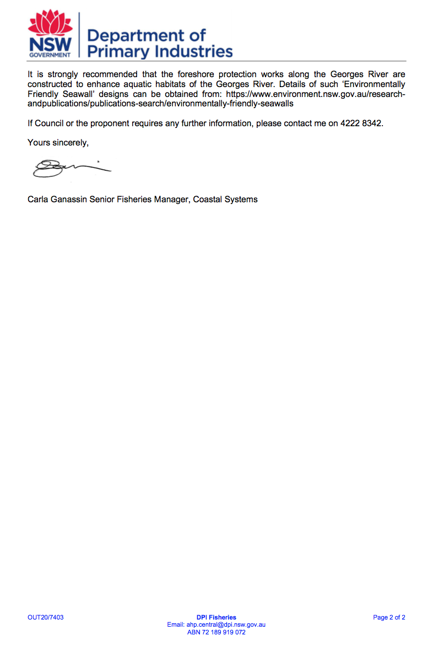

ATTACHMENT 4 - REQUIREMENTS OF NSW ENVIRONMENT PLANNING AUTHORITY
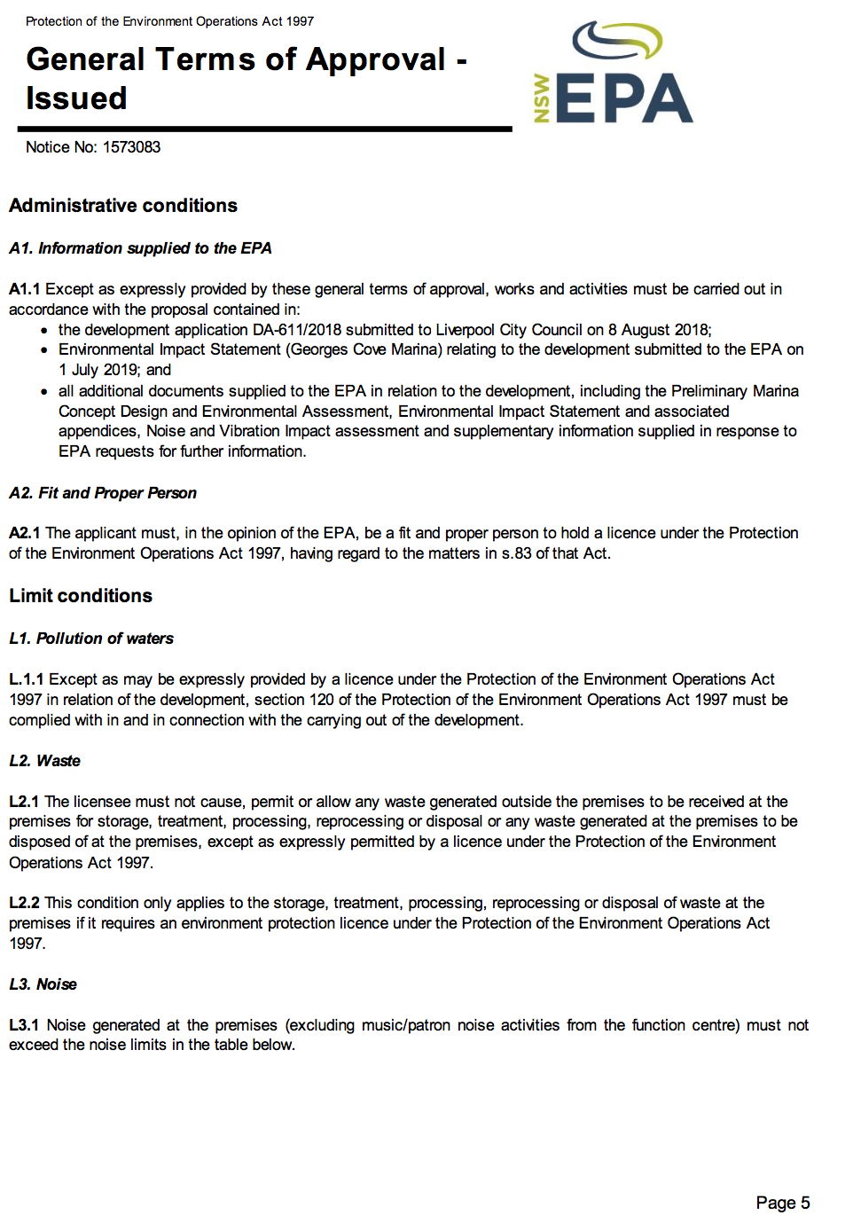
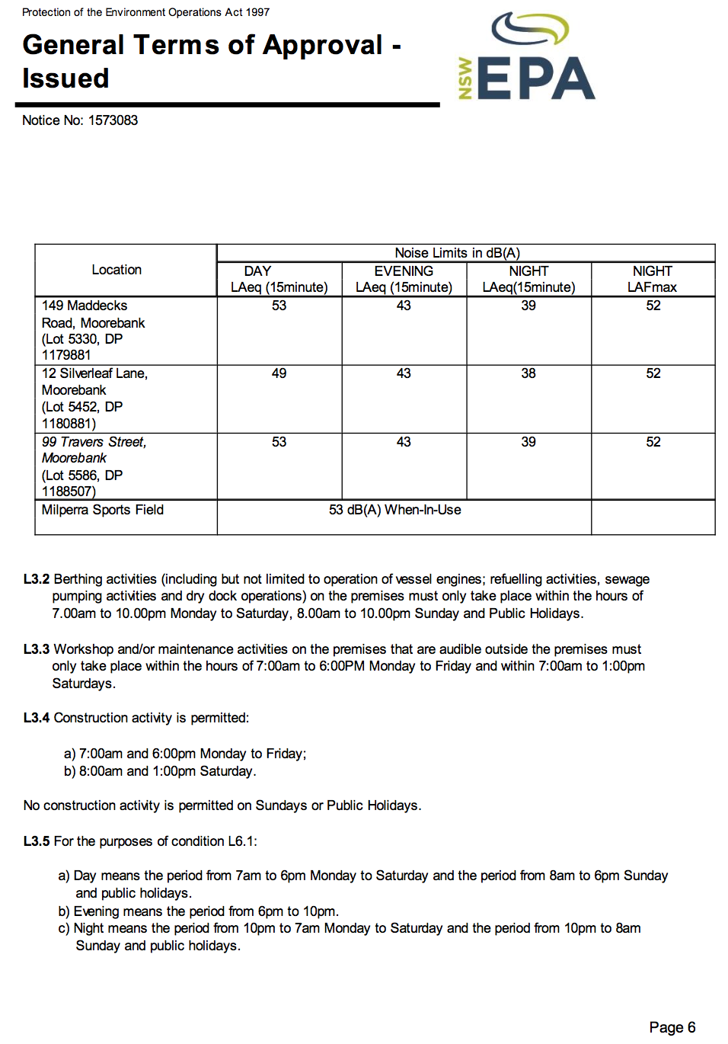
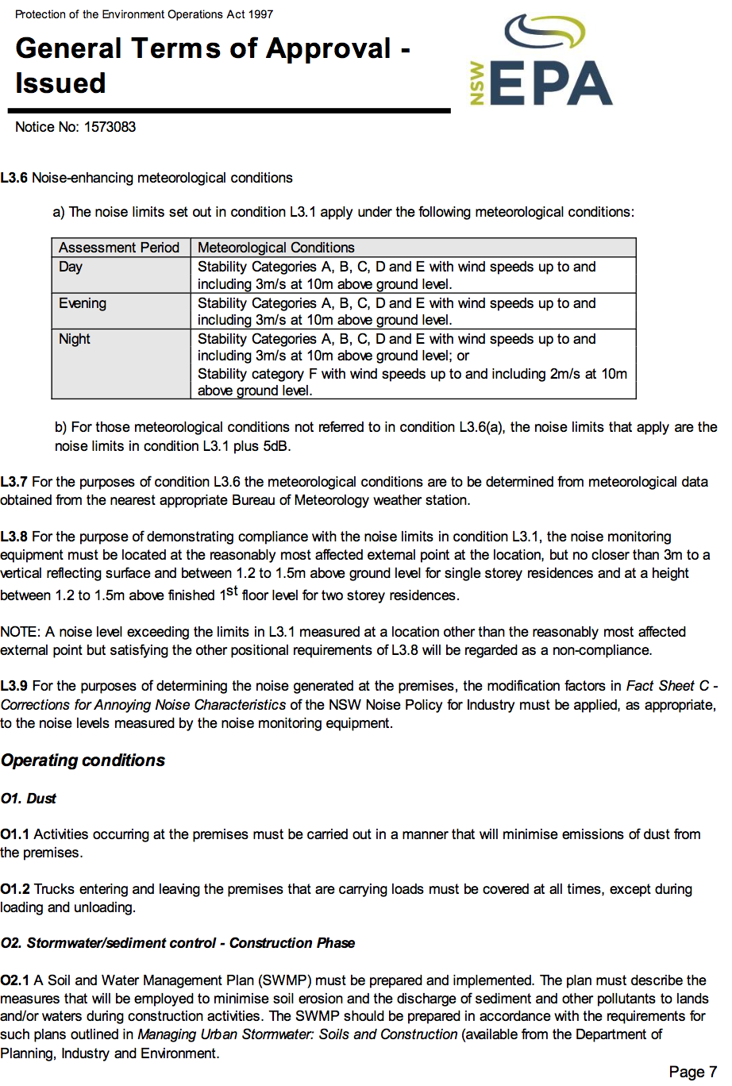
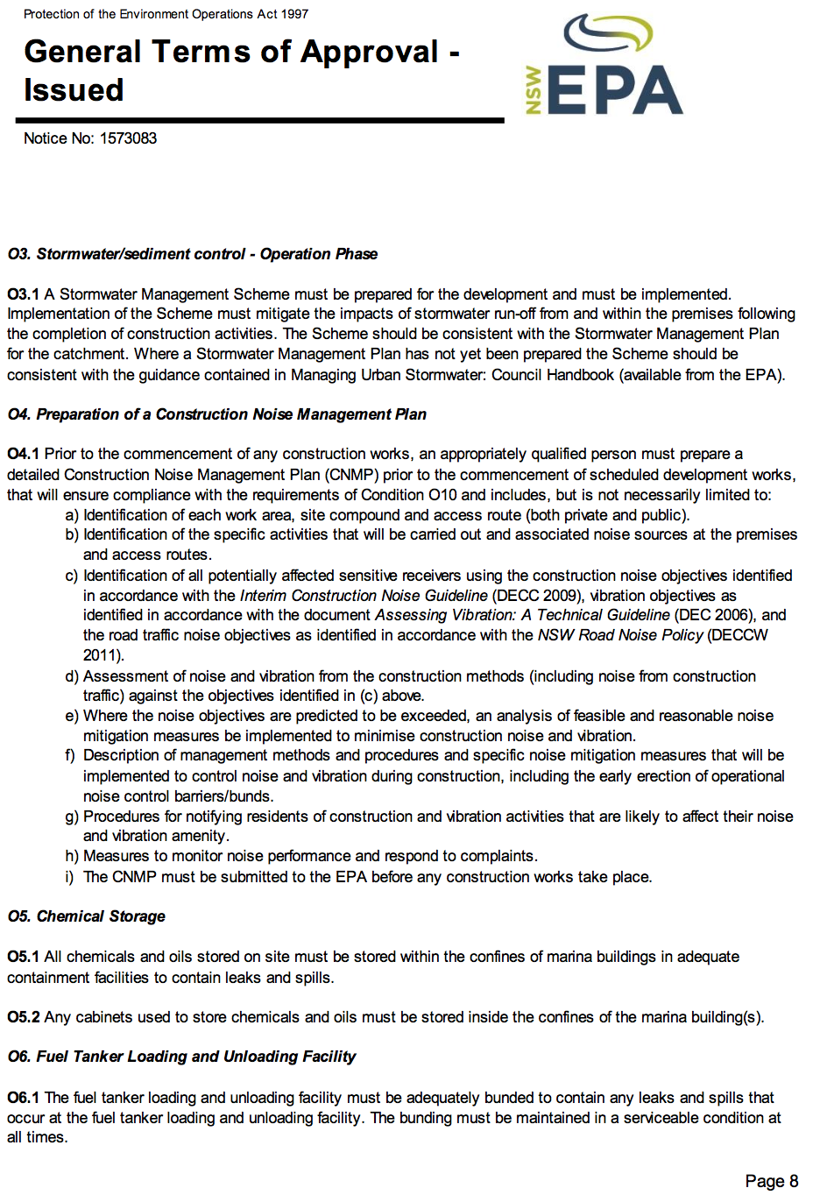
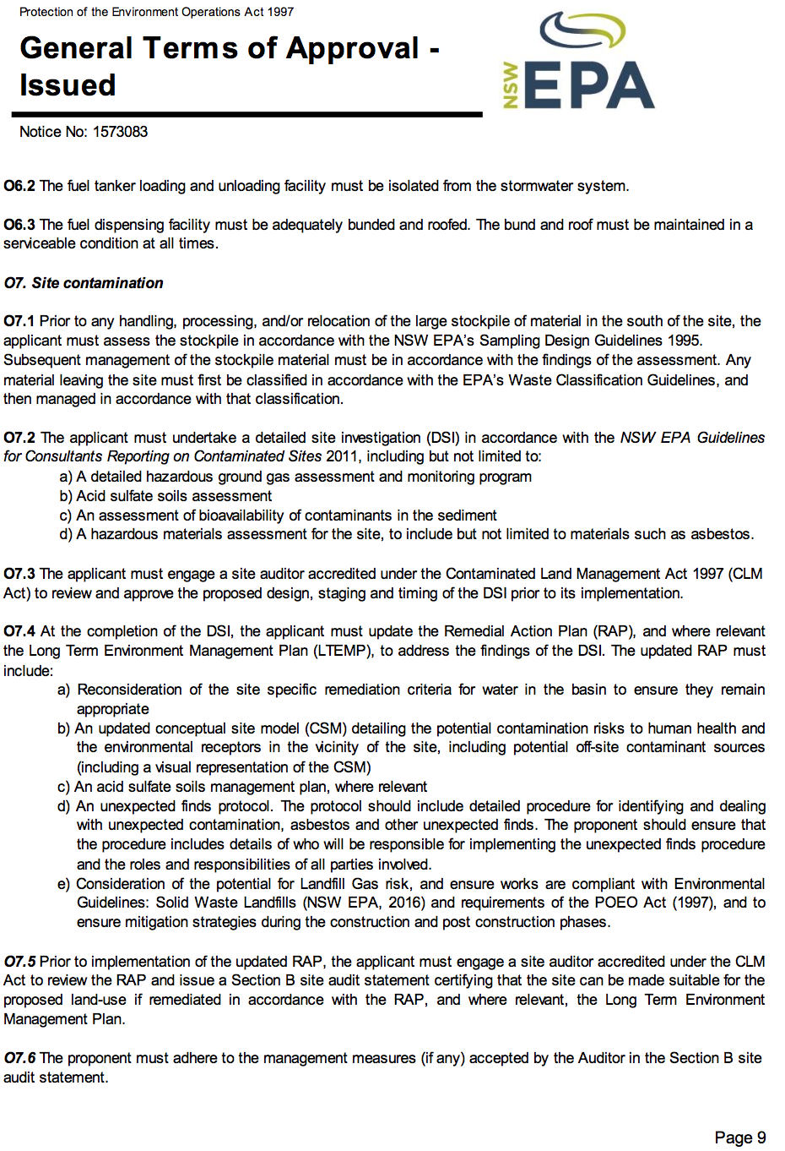
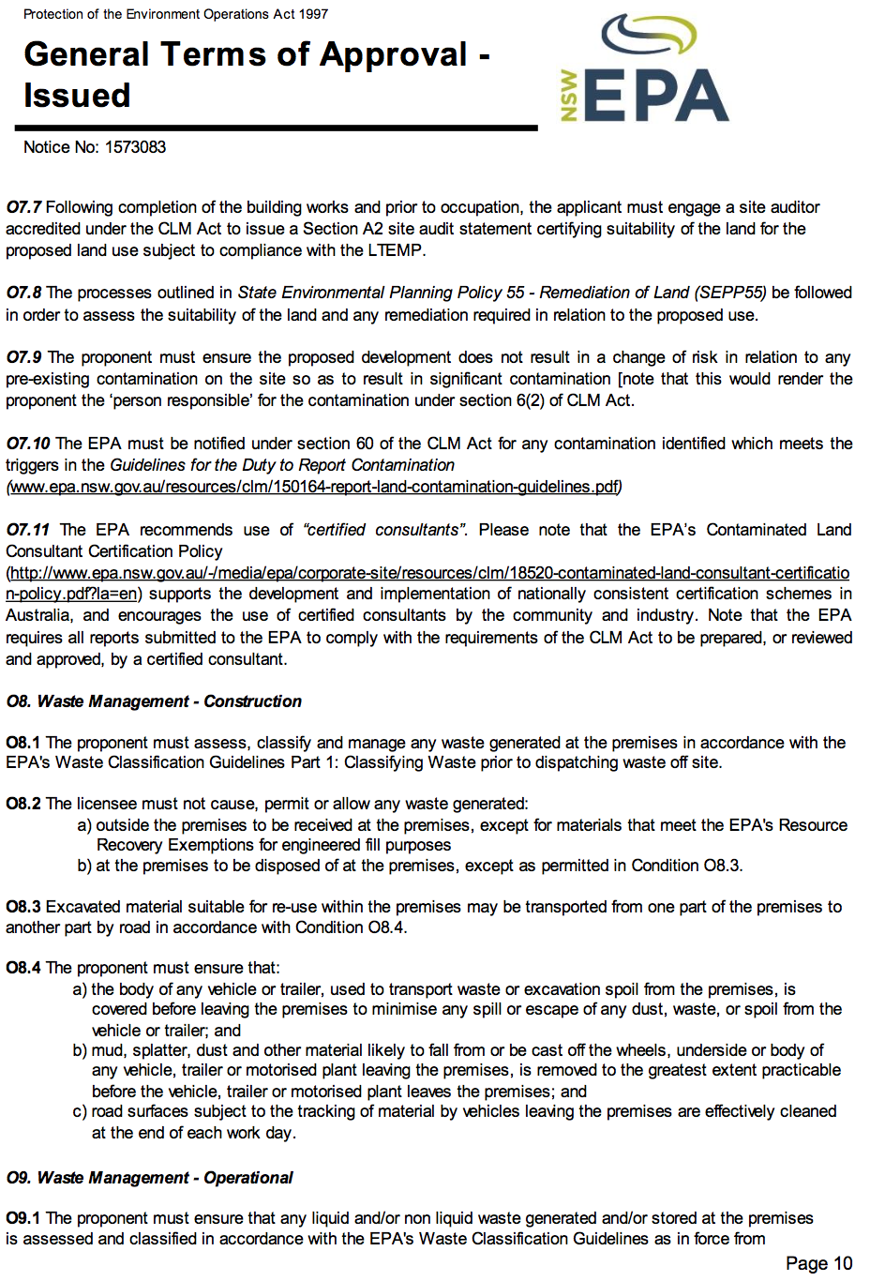
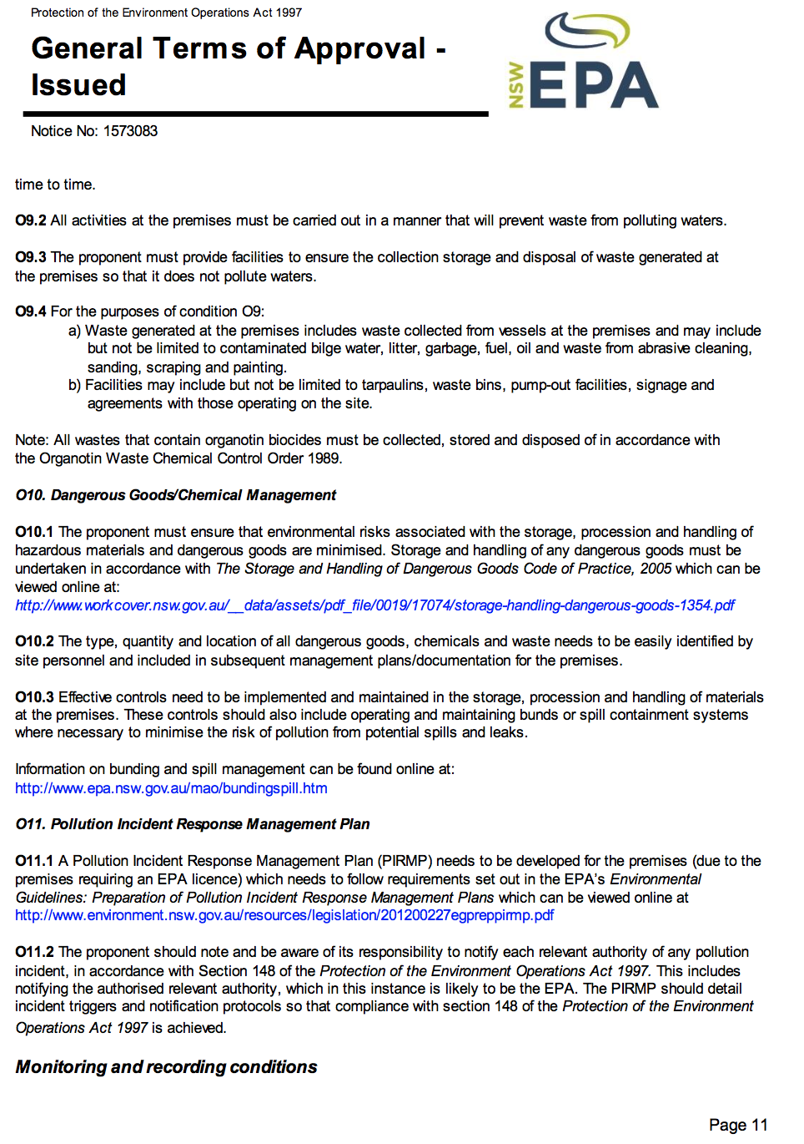
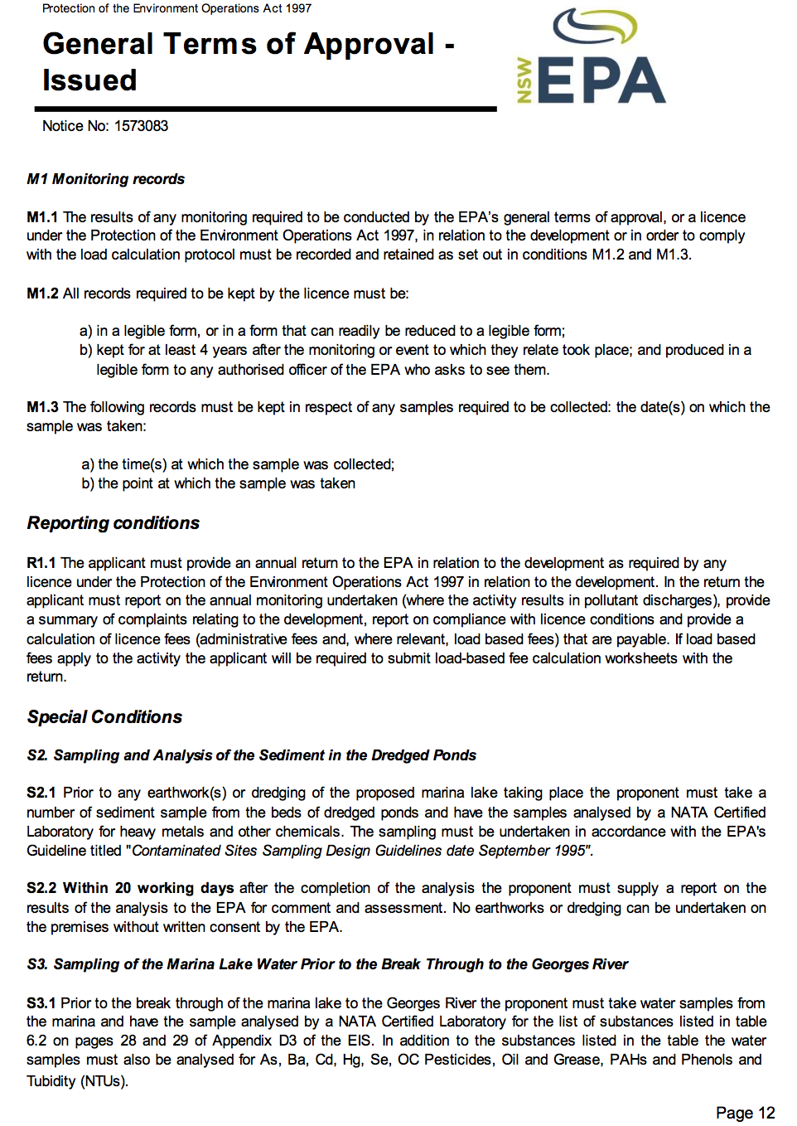
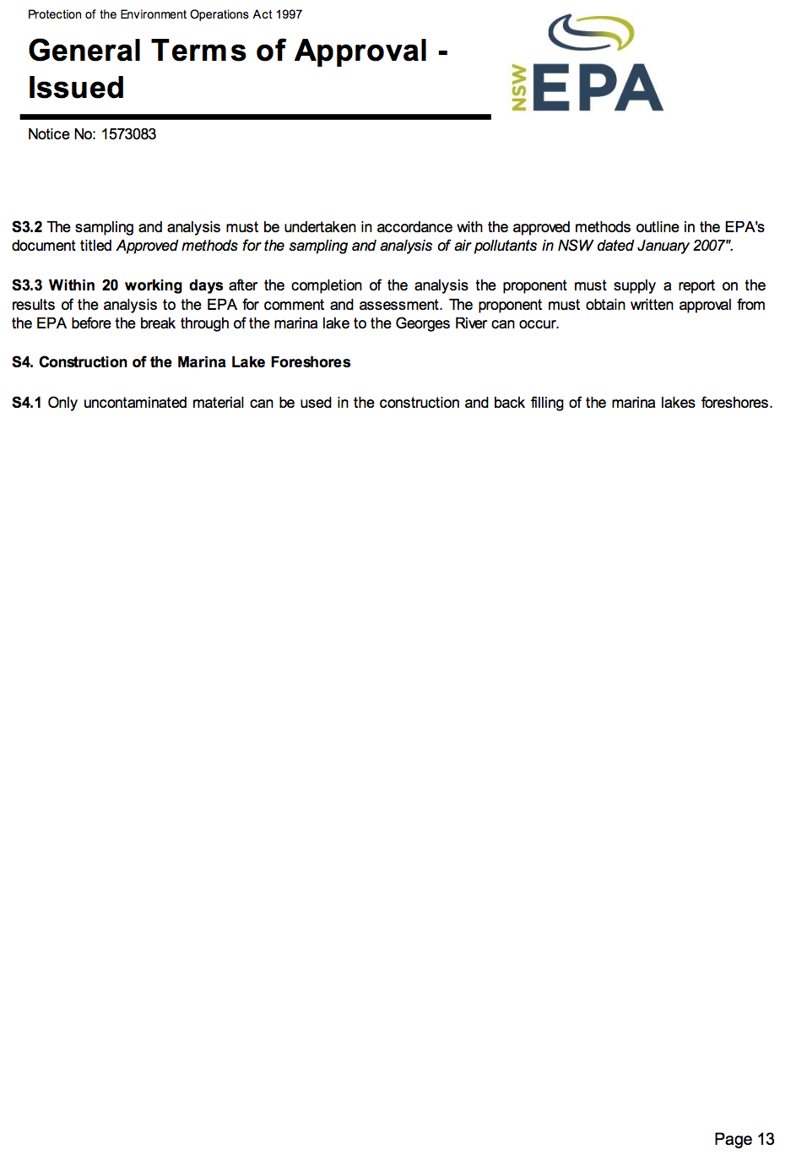
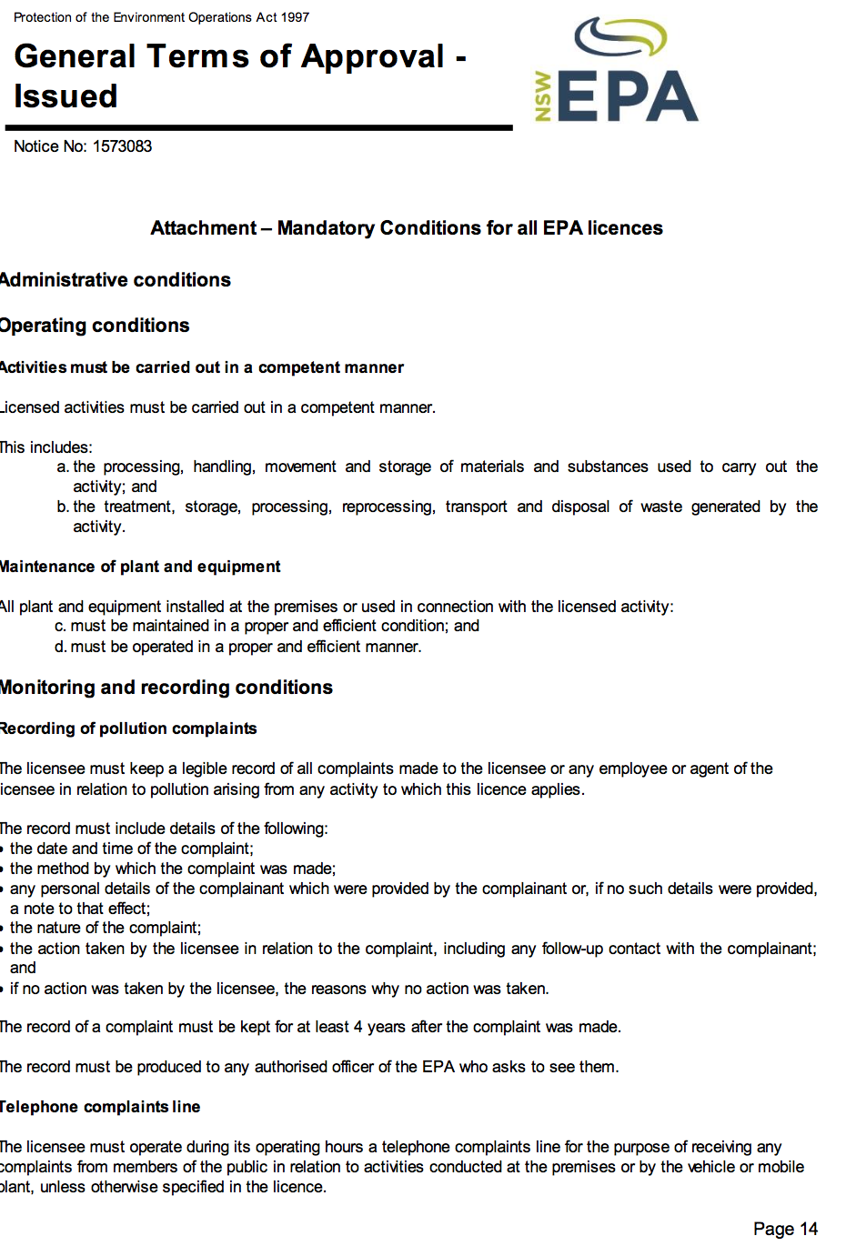
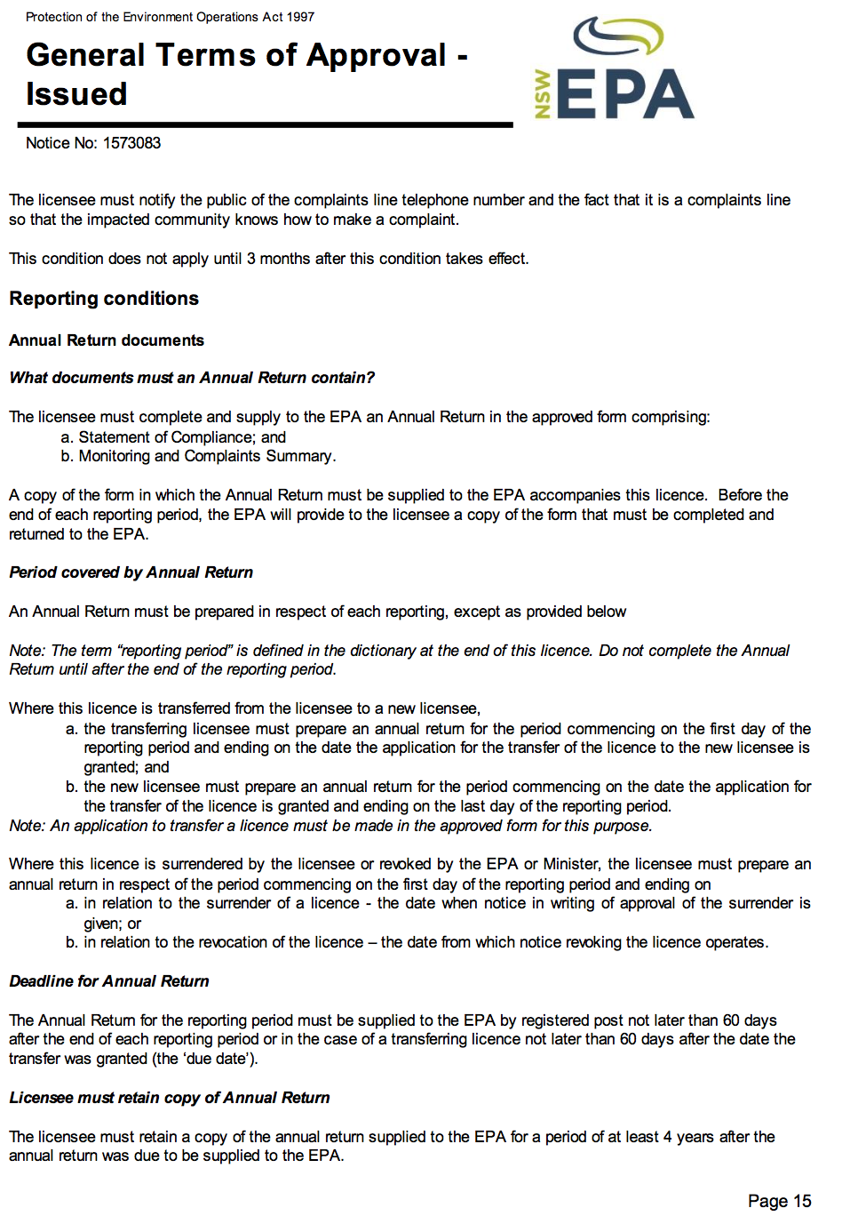
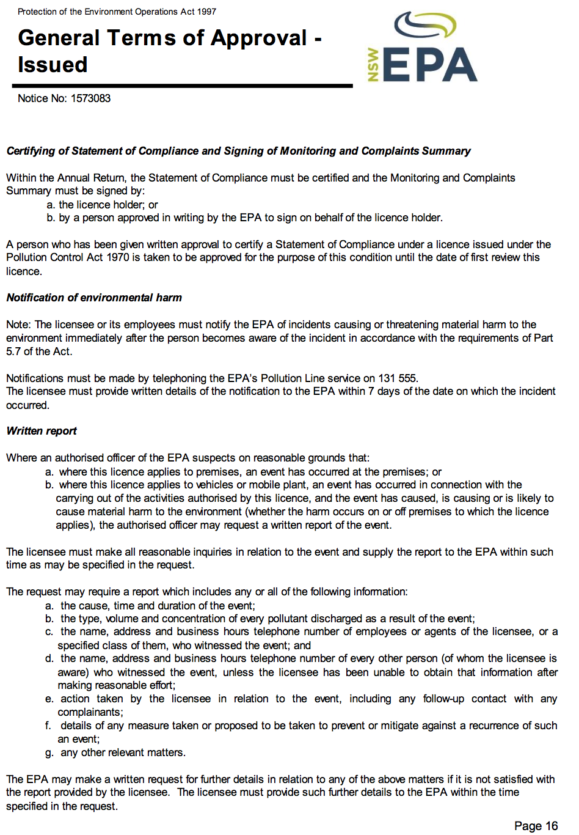
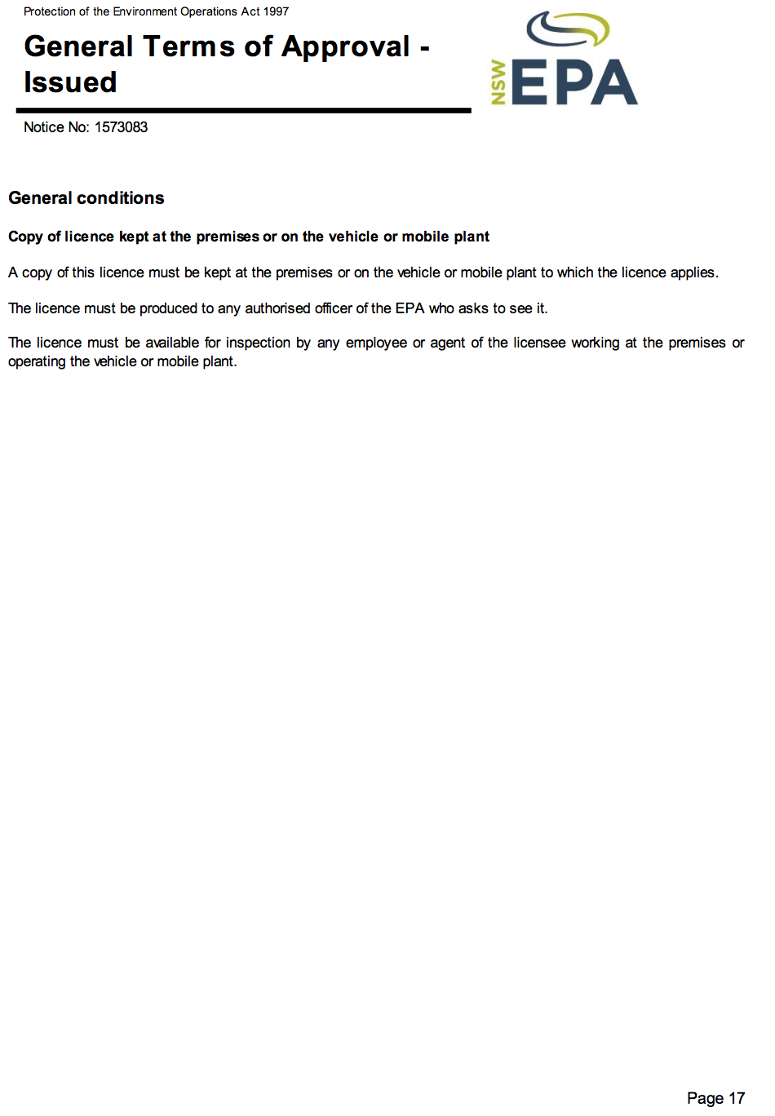

ATTACHMENT 5 - REQUIREMENTS OF NSW RURAL FIRE SERVICE
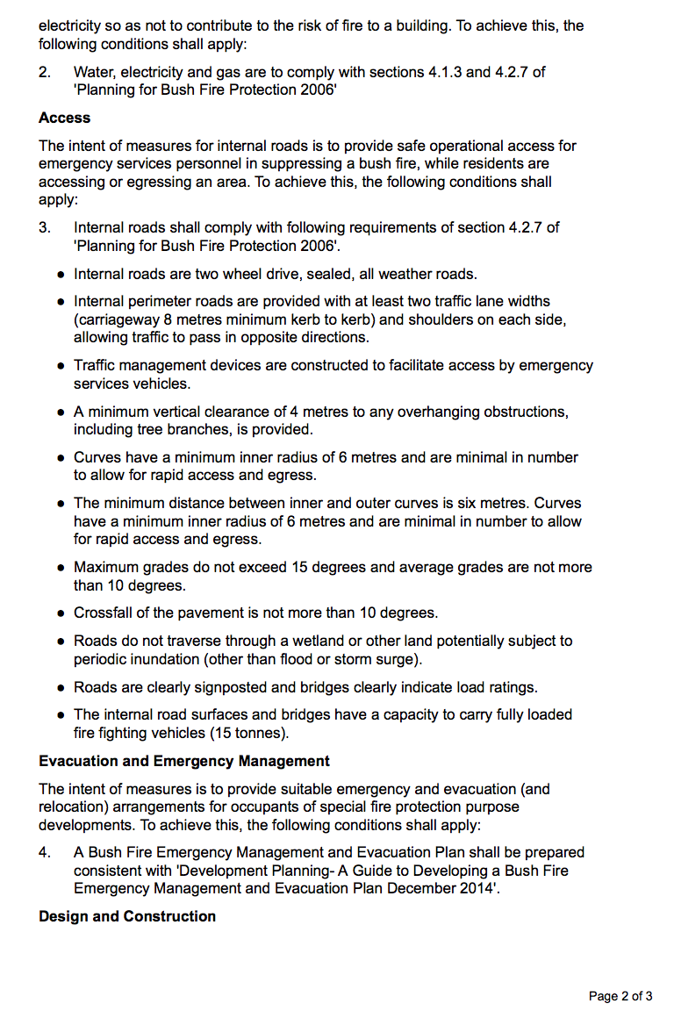
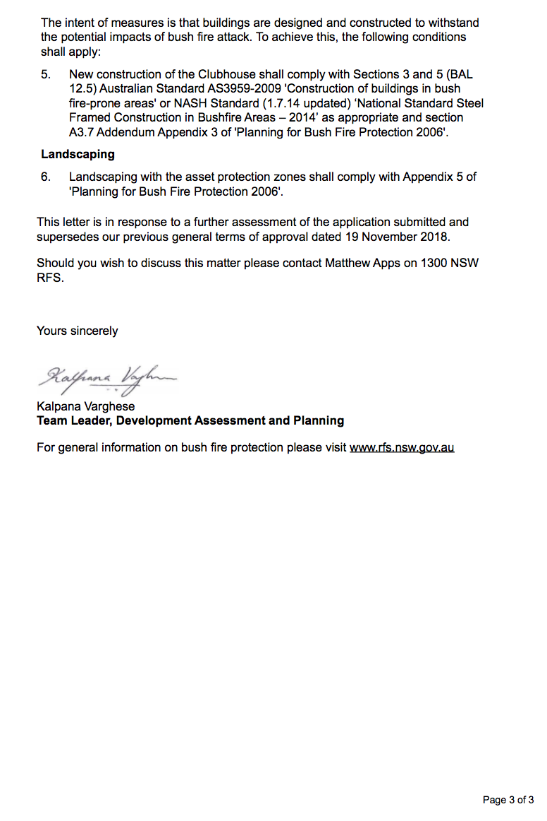

ATTACHMENT 6 - REQUIREMENTS OF TRANSPORT FOR NSW
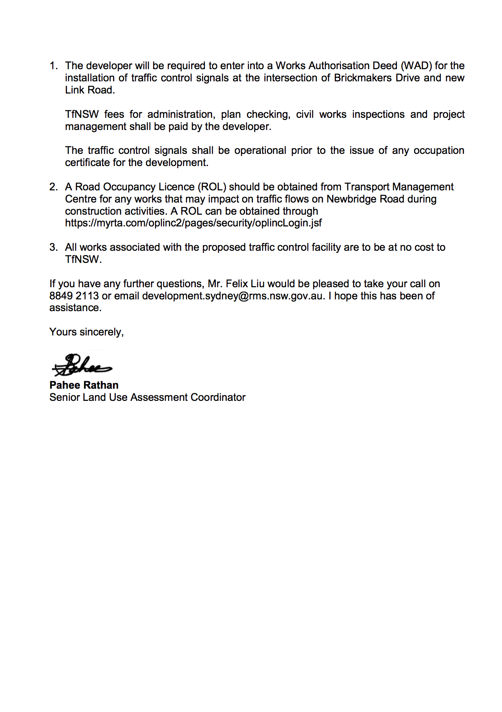

ATTACHMENT 7 - REQUIREMENTS OF SYDNEY WATER
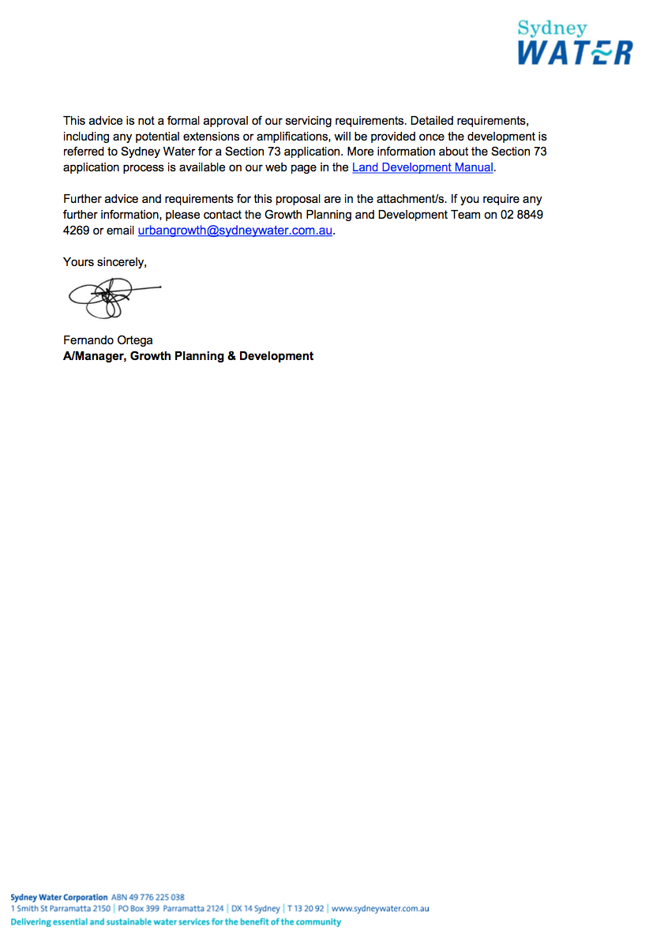
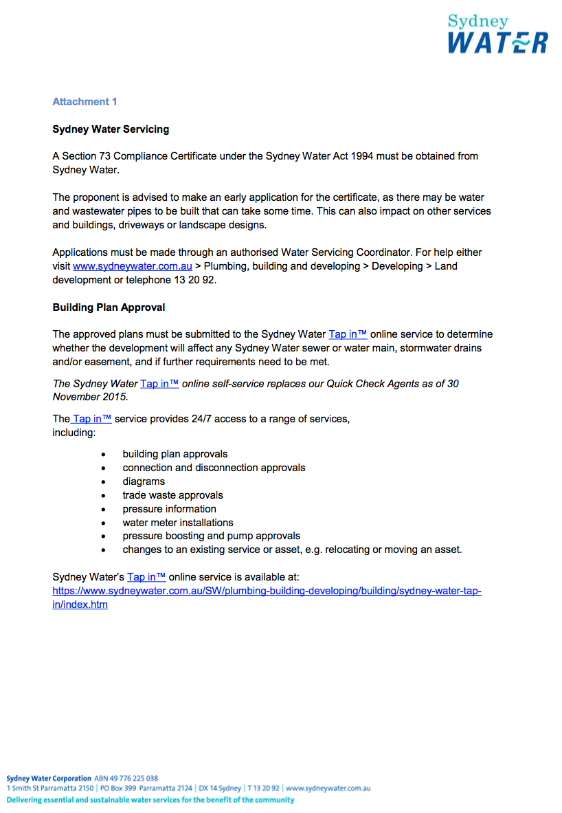
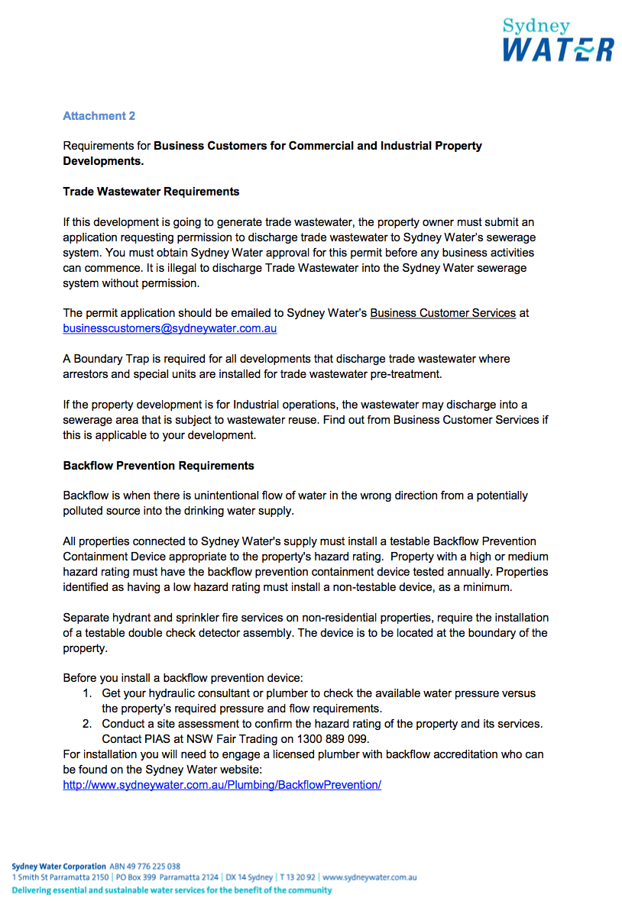
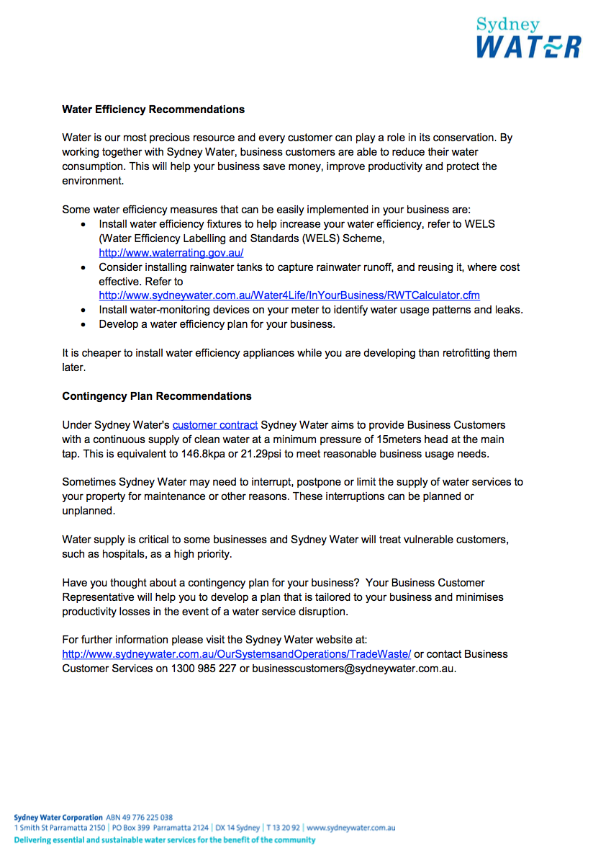

ATTACHMENT 8 - REQUIREMENTS OF ENDEAVOUR ENERGY
